Université d’Ottawa

Faculté de génie



University of Ottawa

Faculty of Engineering

**ELG5901 Electrical Engineering Project (Template)**

**Final Report:**

Cover Page

# Student name Rim Mahmoud Sayed Touny ID 300389922

# Student name Nada Mohamed Zakaria Elsaid Elseddik ID 300389901

# Student name Sema Abdel Nasser Mosaad ID 300389914

# Student name Dina Ibrahim Mohammady ID 300389383

# Graduate Program AI_Wakeb16_2023

**Semester to Register 2023-Winter**

**(Indicate: Year & Fall, Winter, or Spring)**

**Project Title Video Deepfake Detection**

**Version 01winter-2022**

**Table of Contents:**

1. Introduction 8

***1.1 Problem Definition: DeepFakes:*** 8

***1.2 Background*** 9

***1.3 Project Context*** 10

2. Design Overview 12

***2.1 Requirements*** 13

❖ Sponer Requirements 13

❖ System Requirements 13

***2.2*** ***Detailed Design*** 14

**1.** ***Business understands*** 14

***2.*** ***Data Collection*** 14

***3.*** ***Data Exploration*** 14

***4.*** ***Video Processing*** 14

***5.*** ***Data Preprocessing*** 14

***6.*** ***Data Preparation*** 14

***7.*** ***Model Creation and Training*** 14

***8.*** ***Evaluation and Result Analysis*** 15

***9.*** ***Cross-Validation*** 15

***10.*** ***Soft Voting*** 15

***11.*** ***Hyperparameters Tuning*** 15

***12.*** ***Overall Comparison and The Superior Model*** 15

***13.*** ***Deployment Phase*** 15

***2.3***  ***Implementation*** 16

**1.** **Data Exploration** 16

***2.*** ***Video Processing*** 16

***3.*** ***Face Detection*** 18

***4.*** ***Data Preprocessing*** 20

***5.*** ***Data Splitting*** 21

***6.*** ***Data Preparation*** 23

***7.*** ***Model Creation and Training*** 24

***8.*** ***Evaluation and Result Analysis***  40

***9.*** ***Cross-Validation on the Champion Model*** *.* 42

***10.*** ***Soft Voting on the Top 3 Models*** 43

***11.*** ***Hyperparameters Tuning on the Champion Model*** 44

***12.*** ***Save the Superior Model: MobileNetV2*** 49

***2.4*** ***Testing*** 50

***2.4.1*** ***Data Plan*** 50

***2.4.2*** ***Validation & Verification*** 51

3. Overall Results and Analysis 62

4. Deployment Plan 70

5. Conclusions and Future Works 78

6. References 79

7. Appendices 80

**Table of Figures:**

Figure 1:Project Structure 12

Figure 2:Analyzing Videos for 1-Second Intervals. 16

Figure 3:Analyzing Video Frames with Detailed Metadata for 1-Second Intervals. 16

Figure 4:Analyzing Videos for 2-Second Intervals. 17

Figure 5:Analyzing Video Frames with Detailed Metadata for 2-Second Intervals. 17

Figure 6:Analyzing Videos at 4-Second Intervals 17

Figure 7:Analyzing Video Frames with Detailed Metadata for 4-Second Intervals. 17

Figure 8:Sample for Detecting Faces for 1-second Interval. 18

Figure 9:Sample for Detecting Faces for 2-second Interval. 19

Figure 10:Sample for Detecting Faces for 4-second Interval. 19

Figure 11:Normalized Frames and Categorical Labels for 1-Second Interval. 20

Figure 12:Normalized Frames and Categorical Labels for 2-Second Interval. 20

Figure 13:Normalized Frames and Categorical Labels for 4-Second Interval. 21

Figure 14: Splitting for 1-Second Interval. 21

Figure 15:Splitting for 2-Second Interval. 22

Figure 16:Splitting for 1-Second Interval. 22

Figure 17:Conversion to Tensors for 1,2,4 sec. 23

Figure 18:ResNet50 Model Architecture. 24

Figure 19:Training and Validation Confusion Matrix for ResNet50 Model for 1-sec. 25

Figure 20:Learning and Loss Curve for ResNet50 Model for 1-sec. 25

Figure 21:Training and Validation Confusion Matrix for ResNet50 Model for 2-sec. 26

Figure 22:Learning and Loss Curve for ResNet50 Model for 2-sec. 26

Figure 23:Training and Validation Confusion Matrix for ResNet50 Model for 4-sec. 27

Figure 24:Learning and Loss Curve for ResNet50 Model for 4-sec. 27

Figure 25:InceptionResNetV2 Model Architecture. 28

Figure 26:Training and Validation Confusion Matrix for InceptionResNetV2 Model for 1-sec. 29

Figure 27:Learning and Loss Curve for InceptionResNetV2 Model for 1-sec. 29

Figure 28:Training and Validation Confusion Matrix for InceptionResNetV2 Model for 2-sec. 30

Figure 29:Learning and Loss Curve for InceptionResNetV2 Model for 2-sec. 30

Figure 30:Training and Validation Confusion Matrix for InceptionResNetV2 Model for 4-sec. 31

Figure 31:Learning and Loss Curve for InceptionResNetV2 Model for 4-sec. 31

Figure 32:MobileNetV2 Model Architecture. 32

Figure 33:Training and Valuation Confusion Matrix for MobileNetV2 Model for 1-sec. 33

Figure 34: Learning and Loss Curve for MobileNetV2 Model for 1-sec. 33

Figure 35:Training and Validation Confusion Matrix for MobileNetV2 Model for 2-sec. 34

Figure 36:Learning and Loss Curve for MobileNetV2 Model for 2-sec. 34

Figure 37:Training and Validation Confusion Matrix for MobileNetV2 Model for 4-sec. 35

Figure 38:Learning and Loss Curve for MobileNetV2 Model for 4-sec. 35

Figure 39:VGG16 Model Architecture 36

Figure 40:Training and Validation Confusion Matrix for VGG16 Model for 1-sec 37

Figure 41:Learning and Loss Curve for VGG16 Model for 1-sec. 37

Figure 42:Training and Validation Confusion Matrix for VGG16 Model for 2-sec. 38

Figure 43:Learning and Loss Curve for VGG16 Model for 2-sec. 38

Figure 44:Training and Validation Confusion Matrix for VGG16 Model for 4-sec. 39

Figure 45:Learning and Loss Curve for VGG16 Model for 4-sec. 39

Figure 46:Evaluation Diagram Based on Video. 40

Figure 47:Example of ResNetV2 model using the Test Set in one frame per 1 sec for Evaluation. 41

Figure 48:Training and Validation Confusion Matrix for MobileNetV2 Model for 1-sec with LR=10^-3. 44

Figure 49:Learn and Loss Curve for MobileNetV2 Model for 1-sec with LR=10^-3. 44

Figure 50:Training and Validation Confusion Matrix for MobileNetV2 Model for 1-sec with LR=10^-5. 45

Figure 51:Learn and Loss Curve for MobileNetV2 Model for 1-sec with LR=10^-5. 45

Figure 52:Training and Validation Confusion Matrix for MobileNetV2 Model for 1-sec with BS=16. 46

Figure 53: Learn and Loss Curve for MobileNetV2 Model for 1-sec with BS=16. 46

Figure 54:Training and Validation Confusion Matrix for MobileNetV2 Model for 1-sec with BS=64. 47

Figure 55:Learn and Loss Curve for MobileNetV2 Model for 1-sec with BS=64. 47

Figure 56:Training and Validation Confusion Matrix for MobileNetV2 Model for 1-sec with Early stop=5. 48

Figure 57:Learn and Loss Curve for MobileNetV2 Model for 1-sec with Early stop=5. 48

Figure 58:Number of Fake and Real Videos on the dataset. 50

Figure 59:Testing Confusion Matrix for ReNet50 Model for 1-sec 51

Figure 60:Testing Confusion Matrix for InceptionResNet50 Model for 1-sec 51

Figure 61:Testing Confusion Matrix for MobileNetV2 Model for 1-sec. 52

Figure 62:Testing Confusion Matrix for VGG16 Model for 1-sec. 52

Figure 63:Testing Confusion Matrix for ReNet50 Model for 2-sec. 53

Figure 64:Testing Confusion Matrix for InceptionReNet50 Model for 2-sec. 53

Figure 65:Testing Confusion Matrix for MobileNetV2 Model for 2-sec. 54

Figure 66:Testing Confusion Matrix for VGG16 Model for 2-sec. 54

Figure 67:Testing Confusion Matrix for ReNet50 Model for 4-sec 55

Figure 68:Testing Confusion Matrix for InceptionReNet50 Model for 4-sec 55

Figure 69:Testing Confusion Matrix for MobileNetV2 Model for 4-sec. 56

Figure 70:Testing Confusion Matrix for VGG16 Model for 4-sec. 56

Figure 71:Snapshot from Running MobileNetV2 Model after applying Cross-Validation. 57

Figure 72:Snapshot from code for applying Sof Voting using ResNet50 Model, InceptionResNetV2, MobileNetV2 Model 58

Figure 73:Testing Confusion Matrix for MobileNetV2 Model for 1-sec with LR=10^-3. 59

Figure 74:Testing Confusion Matrix for MobileNetV2 Model for 1-sec with LR=10^-5. 59

Figure 75:Testing Confusion Matrix for MobileNetV2 Model for 1-sec with BS=16. 60

Figure 76:Testing Confusion Matrix for MobileNetV2 Model for 1-sec with BS=64. 60

Figure 77:Testing Confusion Matrix for MobileNetV2 Model for 1-sec with Early Stop=5. 61

Figure 78:Hyperparameters Comparison. 67

Figure 79:Overall Models and Improvement Comparison. 68

Figure 80:Veriflick Homepage. 70

Figure 81:Veriflick About. 70

Figure 82:Veriflick Contact. 71

Figure 83: Veriflick Login Page. 71

Figure 84:Veriflick Registration Page. 72

Figure 85:Veriflick Video Upload Page. 72

Figure 86:Sample of Fake Video. 73

Figure 87:Sample of Real Video. 73

Figure 88:User Information Management Key Elements. 74

Figure 89:Video and Detection Management Key Elements. 75

**Table of Tables:**

Table 1:Model Comparison in Training and Validation sets. 42

Table 2:Training and Validation F1-scores for Different Learning Rates. 45

Table 3:Training and Validation F1-scores for Different Batch Sizes 47

Table 4:Training and Validation F1-scores for Early Stop. 48

Table 5:Model Comparison in Training and Validation sets. 57

Table 6:Testing f1-scorce for Different Learning Rate. 59

Table 7:Testing f1-scorce for Different Batch sizes. 60

Table 8:Testing f1-scorce with early stop=5. 61

Table 9:Overall Performance using F1-score. 62

Table 10:Average Metrics Calculation for Cross Validation. 64

Table 11:Metrics Calculation in Soft Voting. 65

Table 12:Different Learning Rates F1-scores. 66

Table 13:Different Learning Rates F1-scores. 66

Table 14:Different Early Stops F1-scores. 66

**Acronyms**

|  |  |
| --- | --- |
| *Graphics Processing Unit* | *GPU* |
| *Application Programming Interface* | *API* |
| *Structured Query Language* | *MySQL* |
| *Hypertext Markup Language* | *HTML* |
| *Cascading Style Sheet* | *CSS* |
| *High-level, interpreted programming language* | *JavaScript* |
| *F1 Score is the harmonic mean of precision and recall.* | *F1 Score* |
| *Stochastic Gradient Descent* | *SGD* |
| *Computer Vision* | *CV* |
| *You Only Look Once version 8, a popular object detection model.* | *YOLOv8* |
| *Learning Rate* | *LR* |
| *Library Reference Model* | *LRM* |

# 1. Introduction

## ***1.1 Problem Definition: Deepfakes:***

*The rise of deepfakes poses a significant threat to the authenticity of digital information and trust in online interactions. These cleverly synthesized videos, seamlessly merging faces onto existing footage, blur the lines between truth and fiction, making it increasingly difficult to discern real from manipulated content. This has far-reaching consequences, impacting individuals, institutions, and society.*

*The project is important to our sponsor because the impact of deepfakes is multi-faceted:*

* *Misinformation and distrust:   
  Deepfakes can be used to spread false narratives, manipulate public opinion, and undermine faith in traditional media and institutions.*
* *Personal harm and reputational damage:   
  Malicious actors can use deepfakes to create compromising videos of individuals, damaging reputations and causing emotional distress.*

*Erosion of democratic processes: Deepfakes can be used to influence elections by swaying public opinion or even fabricate political scandals.*

*Existing deepfake detection methods face critical limitations:*

* *Inaccurate or easily fooled:   
  Many approaches struggle to accurately distinguish real from deepfake videos, especially with the constant evolution of manipulation techniques.*
* *Computationally expensive:   
  Some methods require significant computing resources, limiting their scalability and real-time applicability.*
* *Technical barriers:   
  Existing solutions often require technical expertise, hindering widespread adoption and user-friendliness.*

*By successfully addressing these limitations, the project offers significant benefits:*

* *Combating misinformation and protecting trust:   
  Improved accuracy and access will empower individuals to discern truth from falsehood online, mitigating the spread of misinformation and safeguarding trust in media and institutions.*
* *Safeguarding individuals and reputation:   
  Early detection and prevention of deepfakes will protect individuals from reputational damage and personal harm associated with malicious manipulation.*

*To address these challenges, the Deep Fake Video Detection project proposes a novel approach:*

* *Developing a highly accurate detection model:  
   Leveraging cutting-edge deep learning algorithms and advanced analysis techniques, we aim to achieve unparalleled accuracy in identifying deepfakes, even those created with sophisticated methods.*
* *User-friendly web interface:  
   Democratizing access to deepfake detection, we will develop a user-friendly web platform accessible to anyone, regardless of technical background.*
* *Continuous Model Enhancement:*

*Implementing an iterative model improvement process ensures the adaptation to emerging deepfake techniques. Regular updates and refinements to the detection model keep it at the forefront of technological advancements in the field.*

*Ultimately, the Deep Fake Video Detection project aspires to empower individuals and communities to navigate the digital landscape with greater confidence and discernment. It represents a resolute stand against the weaponization of digital deception, paving the way for a more informed and transparent society.*

## ***1.2 Background***

*Deepfake Detection identifies fake visuals created using deep learning, which manipulate or replace original content, often focusing on facial features, through machine learning techniques.*

* *Academic Beacons:*
* *"Deepfake Detection: A Systematic Literature Review" by Wang et al. (2022):  
   This comprehensive study serves as a crucial roadmap, meticulously analyzing existing deep learning-based detection approaches. Their categorization of methods, evaluation of performance metrics, and emphasis on the field's evolution provide invaluable insights for selecting and prioritizing techniques. This foundation guides our project design and validation, ensuring alignment with the current state-of-the-art in deepfake detection.*
* *"Deepfake Detection for Human Face Images and Videos: A Survey" by Zhou (2022): This insightful survey offers a wider lens, delving into the advancement of deepfake technology, its applications, and potential risks. By focusing on deep neural network detection methods for facial manipulation, they categorize techniques based on factors like architectural choices and training objectives. Their analysis of creation techniques, datasets, and challenges empowers us to develop a robust system that addresses the nuances of real-world deepfakes.*
* *Industry Footprints:*
* *"Deepfake Videos in the Wild: Analysis and Detection" by Agarwal et al. (2022):   
  This groundbreaking study shines a light on the practical concerns of deepfakes by introducing the largest real-world dataset of its kind. Analyzing the growth, popularity, and creation methods of deepfakes in the wild, they expose the limitations of existing detection systems. Their exploration of transfer learning and competition techniques provides valuable inspiration for strengthening our defenses against evolving manipulation methods.*
* *"FInfer: Frame Inference-Based Deepfake Detection for High-Visual-Quality Videos" by Zhao et al. (2022): This cutting-edge research paves the way for more efficient and accurate detection of sophisticated deepfakes. Leveraging autoregressive models and a novel representation prediction loss, FInfer demonstrates promising performance in discriminating between real and manipulated videos.*
* *Foundational Textbooks:*

*In addition to the academic and industry literature, our research is anchored by key textbooks that provide foundational knowledge and technical expertise in our field.*

* *"Handbook of Digital Face Manipulation and Detection (2022)" It presents a balanced view by exploring both the creation and detection aspects of these digital manipulations, serves as a valuable resource for understanding the technological underpinnings and methodological approaches.*
* *"Mastering OpenCV 4 with Python" by Alberto Fernandez Villan (2019): This practical guide is pivotal for our technical development, particularly in the application of image processing and deep learning techniques, it’s crucial for implementing effective deepfake detection algorithms and for handling the intricacies of image and video processing tasks.*

*These resources not only provide theoretical knowledge but also practical insights, enabling us to bridge the gap between conceptual understanding and real-world application.*

## ***1.3 Project Context***

*In our deepfake video detection project, we engage with several external systems, third-party interfaces, and key organizations to ensure the successful completion of our objectives:*

* *External Systems and Data Sources:*
* *Wakeb Dataset:   
  We rely on a dataset provided by Wakeb, which includes a diverse range of real and deepfake videos. This dataset is essential for training and testing our detection model.*
* *Development Tools and Third-Party Interfaces:*
* *TensorFlow: Our primary tool for developing the deepfake detection model is TensorFlow, a widely used open-source platform for machine learning.*
* *GPU*
* *s: To handle the intensive computational demands of video processing and machine learning tasks, we use external GPU resources.*
* *APIs: We incorporate various APIs for data handling, process automation, and integration of different software components.*

*MySQL Database: For data management, we utilize a MySQL database, essential for storing, managing, and retrieving video data and analysis results.*

* *Web Development Technologies:*
* *HTML, CSS, and JavaScript:   
  These technologies are used to develop the user interface, providing a user-friendly platform for interacting with our system.*
* *Result Delivery:   
  Clear result presentation with confidence scores and actionable insights*
* *Organizations and Individuals:*
* *There are no individual organizations, we will only deal with Wakeb*
* *Key Dependencies*
* *Computational Resources:*
* *Availability of sufficient computational resources, including GPUs, for model training.*
* *Access to cloud resources if cloud computing is utilized for resource scalability.*
* *Access to cvlib Library:*
* *Dependence on the availability and functionality of the cvlib library for face detection.*
* *Access to Veriflick for Deployment:*
* *Access to Veriflick for deployment purposes.*

# 2. Design Overview

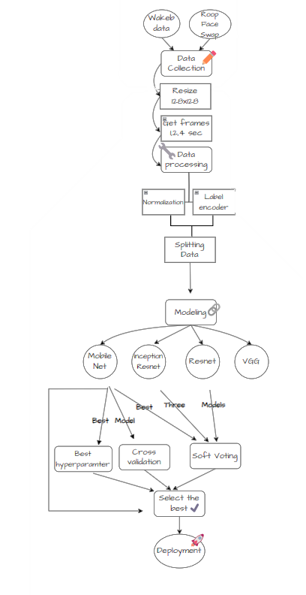*The deepfake detection system utilizes a multi-stage approach involving data preprocessing, feature extraction, deep learning-based classification, and a user-friendly web interface. It employs state-of-the-art algorithms to distinguish between authentic and manipulated videos, addressing the challenge of deepfake proliferation.*

Figure 1:Project Structure

## ***2.1 Requirements***

### Sponer Requirements

* *Accuracy and Authenticity Verification:*
* *The system has to offer a sturdy and dependable mechanism to confirm the authenticity of video content material and make sure that it has no longer been manipulated using deepfake generation.*
* *The device must reduce fake positives (incorrectly figuring out true content as deepfake) and false negatives (failing to identify real deepfake content).*
* *Continuous development mechanisms, consisting of machine learning model updates, must be in vicinity to deal with evolving deepfake techniques.*
* *User-Friendly Interface:*
* *The give up-consumer interface ought to be intuitive and consumer-friendly, enabling smooth navigation and interplay for users with varying degrees of technical know-how.*
* *Stakeholders expect a system this is handy and usable by means of a huge range of users.*
* *Customization and Adaptability*
* *The gadget should permit for personalization to evolve evolving deepfake techniques and new challenges.*
* *Stakeholders may also require the capacity to nice-track parameters and algorithms primarily based on specific use instances or scenarios.*
* *Compliance with Ethical Standards:*
* *Ensure that the task adheres to ethical standards and tips, addressing worries associated with bias, fairness, and unintentional consequences of the deepfake detection gadget.*
* *Scalability:*
* *The machine ought to be scalable to address a developing extent of virtual media content, adapting to the increasing incidence of deepfake generation.*

### System Requirements

* *Processing power needed (GPU).*
* *Libraries:*

|  |  |
| --- | --- |
| * *OpenCV: Version installed: 4.8.1.78* | * *NumPy: Version 1.24.3* |
| * *cvlib* | * *Matplotlib: Version 3.7.2* |
| * *TensorFlow: Version: 2.15.0* | * *Kears: Version 2.15.0* |
| * *scikit-learn: Version: 1.3.0* |  |

## ***2.2 Detailed Design***

*Detailed design is crucial in deep fake video detection, encompassing intricate algorithms.*

*and methodologies that scrutinize pixel-level anomalies and behavioral patterns,*

*ensuring a robust defense against the deceptive intricacies of synthetic media.*

### ***Business understands.***

* *Detect and classify Deepfake videos using computer vision and machine learning techniques.*

### ***Data Collection***

* *From Wakab company and internally generated data using the ROOP Face Swap technique.*

### ***Data Exploration***

* *Number of Real and Fake Videos*

### ***Video Processing***

* *Frame Extraction:*
* *Videos processed to extract frames at intervals (1Frame per 1s, 2s, 4s).*
* *Frames resized to 128x128 pixels.*
* *Store Metadata (Video ID, Frame ID, Video Label).*
* *Face Detection:*
* *Utilizes cvlib for face detection.*
* *Images resized to 300x300.*
* *Draw Rectangles around detected faces in frames.*

### ***Data Preprocessing***

* *Normalization: Pixel values normalized to [0, 1].*
* *Label Encoding: Encode Labels (fake/real).*
* *Data split using the train_test_split function from scikit-learn into training, validation, and testing for (1Frame per 1s, 2s, 4s) intervals.*

### ***Data Preparation***

* *Conversion of data to TensorFlow tensors.*
* *Different durations (1s, 2s, 4s) of video data processed separately.*

### ***Model Creation and Training***

* *ResNet50 Model (for 1 Frame per 1s, 2s, 4s durations):*
* *Transfer Learning with a pre-trained ResNet50 on ImageNet.*
* *Custom Layers: Global Average Pooling, Dense Layers.*
* *Model Compilation: Adam optimizer, Learning Rate: ${10}^{-3}$, Categorical Cross-Entropy Loss.*
* *Training: 100 Epochs, Batch Size: 32, Early Stopping (patience = 5).*
* *InceptionResNetV2 Model (for 1 Frame per 1s, 2s, 4s durations):*
* *Transfer Learning with InceptionResNetV2.*
* *Similar architecture to ResNet50.*
* *MobileNetV2 Model (for 1 Frame per 1s, 2s, 4s durations):*
* *Transfer Learning with MobileNetV2.*
* *Similar architecture to ResNet50.*
* *VGG16 Transfer Model (for 1 Frame per 1s, 2s, 4s durations):*
* *Transfer Learning with VGG16.*
* *Different optimizer (SGD) compared to other models.*

### ***Evaluation and Result Analysis***

* *Confusion matrix based on a threshold for video label determination.*
* *F1 Score and Accuracy Calculation.*
* *Learning and Loss Curve Based on Video.*
* *Model Comparison and Analysis to get the champion model.*

### ***Cross-Validation***

* *Model Selection: Champion model from Model Comparison in [8. Evaluation and Result Analysis]*
* *Data Preparation: 5-fold split maintaining class distribution.*
* *Performance Metrics Calculation: Accuracy and F1 score for each fold.*

### ***Soft Voting***

* *Soft Voting function predicting probabilities for Top 3 Models from Model Comparison in [8. Evaluation and Result Analysis]*
* *Threshold set at 0.5 for binary predictions.*

### ***Hyperparameters Tuning***

* *Different Learning Rates:*
* *Original, Increased, and Decreased learning rates for Champion model.*
* *Different Batch Sizes:*
* *Original, Increased, and Decreased batch sizes for Champion model.*
* *Different Epochs in Early Stop:*
* *Original and Modified patience for early stopping.*

### ***Overall Comparison and The Superior Model***

* *Save the Superior Model for development.*

### ***Deployment Phase***

* *using Flask.*

## ***2.3 Implementation***

*Implementation in deep fake video detection involves translating sophisticated detection algorithms into practical solutions, seamlessly integrating advanced technologies to identify and mitigate the ever-evolving challenges posed by synthetic media, enhancing the security landscape in real-world scenarios.*

### **Data Exploration**

* *Data Path: Videos are stored in the directory "E:/finaldata" with subfolders for 'fake' and 'real' videos.*
* *Data Statistics:*
* *Number of Fake Videos: Number of Fake Videos: 1000*
* *Number of Real Videos: Number of Real Videos: 1000*

### ***Video Processing***

* *Frame Extraction:*
* *Videos are processed to extract frames at a specified interval (one frame per 1 second, one frame per 2 second, and one frame per 4 seconds).*
* *Frames are resized to 128x128 pixels.*
* *Metadata such as VideoID, FrameID, and Labels are stored.*
* *One frame per 1 second*

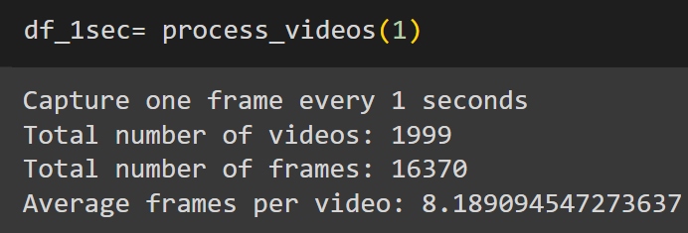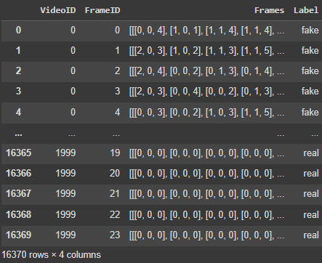

Figure 2:Analyzing Videos for 1-Second Intervals.

Figure 3:Analyzing Video Frames with Detailed Metadata for 1-Second Intervals.

* *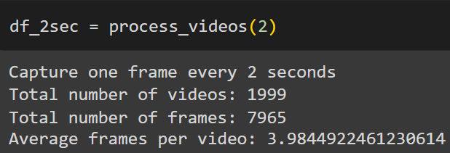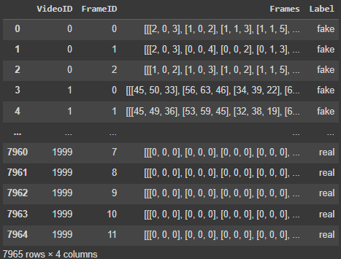One frame per 2 second*

Figure 4:Analyzing Videos for 2-Second Intervals.

Figure 5:Analyzing Video Frames with Detailed Metadata for 2-Second Intervals.

* *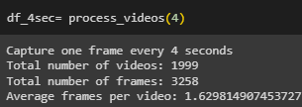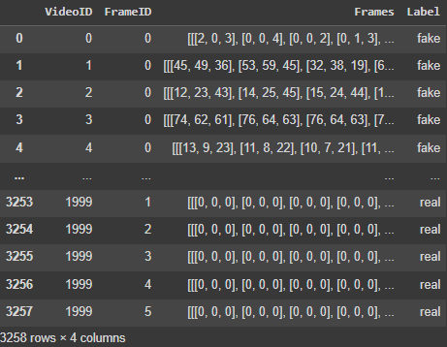One frame per 4 second*

Figure 6:Analyzing Videos at 4-Second Intervals

Figure 7:Analyzing Video Frames with Detailed Metadata for 4-Second Intervals.

### ***Face Detection***

* *Detection Function:*
* *Utilizes cvlib for face detection: For face detection, the cvlib library, a Python library for computer vision tasks, was utilized. It employs pre-trained deep learning models for face detection, simplifying the process without requiring in-depth knowledge of machine learning. The images are processed to detect faces using cvlib's method, and the modified images, displaying outlined faces, are presented in a grid layout using Matplotlib, showcasing the effectiveness of the face detection process.*
* *Resize Image 300*300*
* *Draws rectangles around detected faces in a subset of frames for visualization.*
* 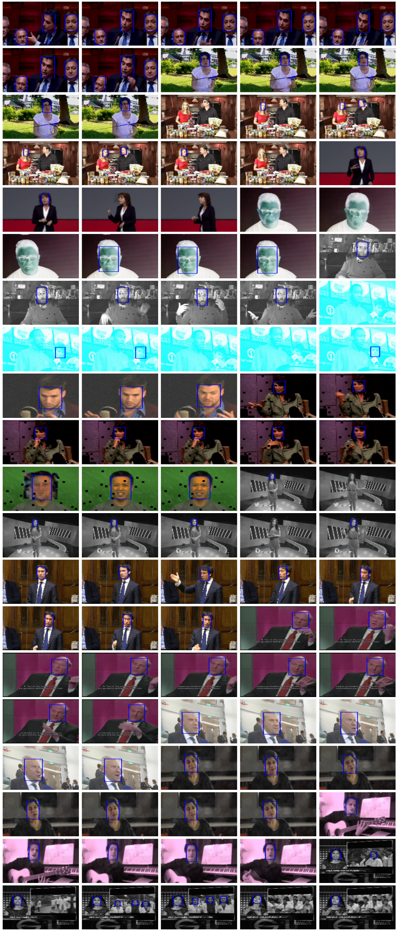*One frame per 1 second*

Figure 8:Sample for Detecting Faces for 1-second Interval.

* *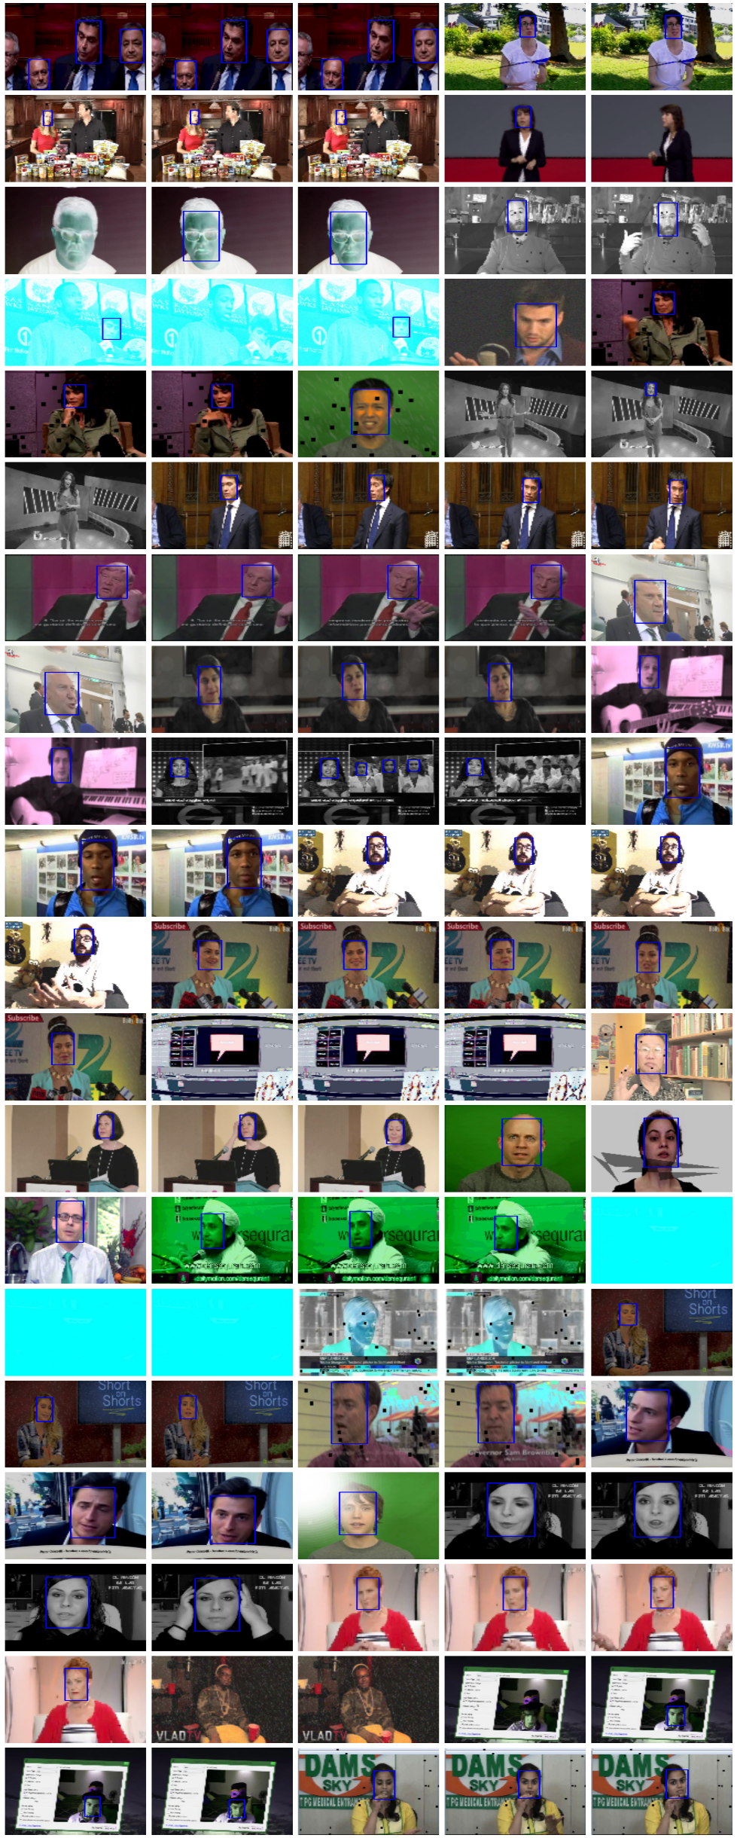One frame per 2 second*

Figure 9:Sample for Detecting Faces for 2-second Interval.

* *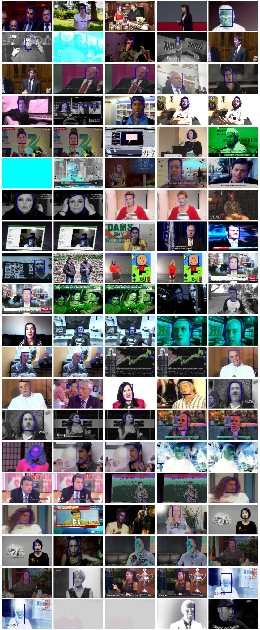One frame per 4 second*

Figure 10:Sample for Detecting Faces for 4-second Interval.

### ***Data Preprocessing***

* *Normalization:*
* *Pixel values of frames are normalized to the range [0, 1].*
* *Label Encoding:*
* *Labels (fake/real) are encoded using LabelEncoder.*
* *Categorical labels are one-hot encoded.*
* *One frame per 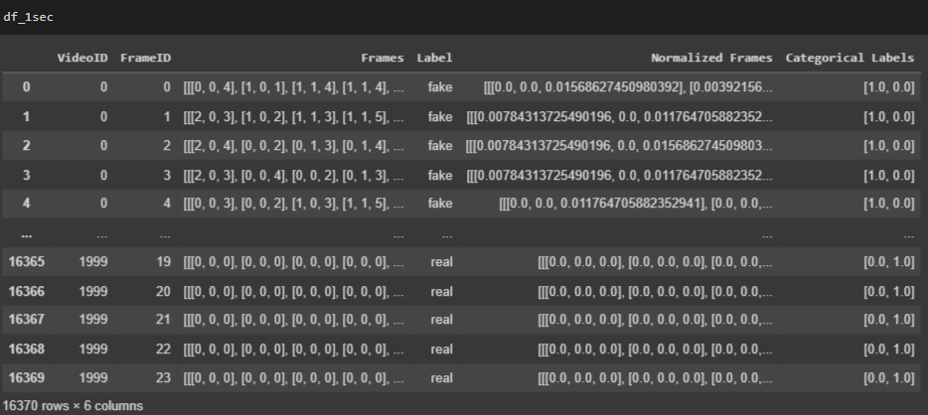1 second*

Figure 11:Normalized Frames and Categorical Labels for 1-Second Interval.

* *One frame per 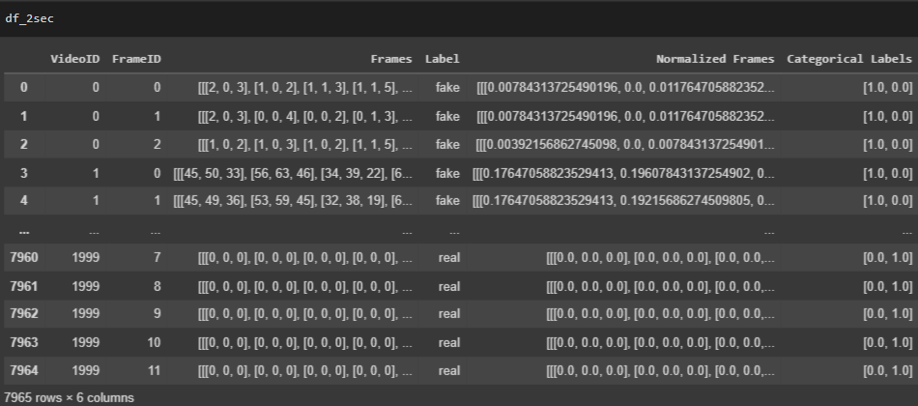2 second*

Figure 12:Normalized Frames and Categorical Labels for 2-Second Interval.

* *One frame per 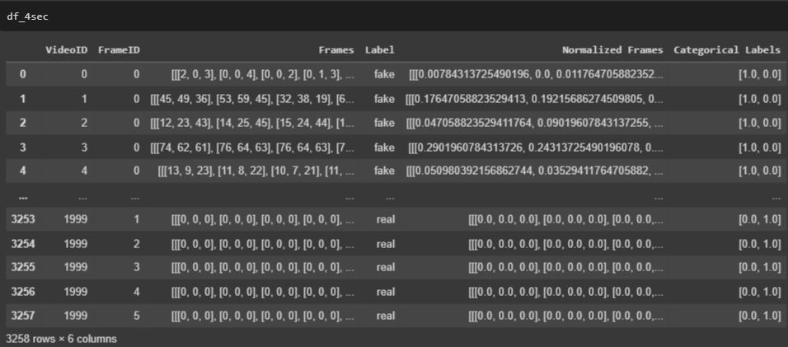 4 second*

Figure 13:Normalized Frames and Categorical Labels for 4-Second Interval.

### ***Data Splitting***

* *Train-Test-Validation Split:*
* *Data is split into 80% training, 10% validation and 10% testing sets for 1, 2, and 4-second intervals.*
* *One frame per 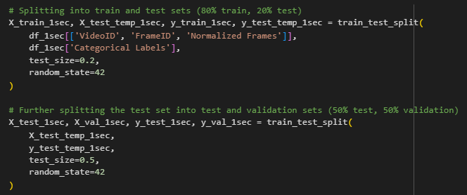1 second*

Figure 14: Splitting for 1-Second Interval.

* *One frame per 2 second*

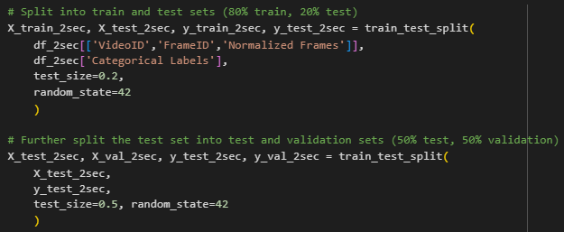

Figure 15:Splitting for 2-Second Interval.

* *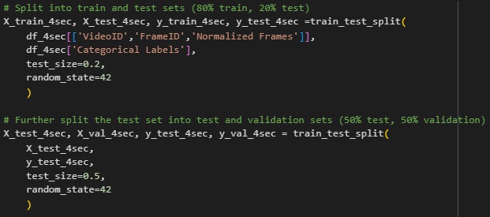One frame per 4 second*

Figure 16:Splitting for 1-Second Interval.

### ***Data Preparation***

* *Conversion to TensorFlow Tensors:*
* *`tf.convert_to_tensor` is used to convert NumPy arrays to TensorFlow tensors.*
* *The normalized frame data and labels for training, validation, and testing sets are converted to TensorFlow tensors.*
* *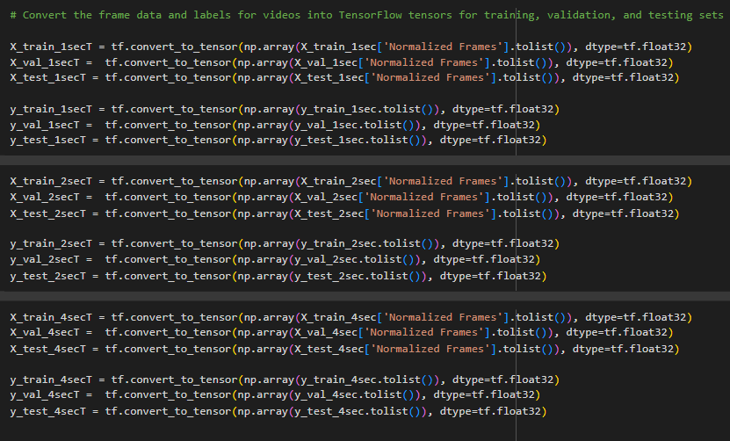 Different durations (1sec, 2sec, 4sec) of video data are processed separately.*

Figure 17:Conversion to Tensors for 1,2,4 sec.

### ***Model Creation and Training***

*The code involves loading pre-trained deep learning models, adding custom classification layers, training the models on video data, and evaluating their performance on training, validation, and test sets. The use of transfer learning allows leveraging features learned from large datasets (e.g., ImageNet) for video classification tasks. Early stopping is implemented to prevent overfitting. The final results provide insights into the models' ability to classify videos based on different durations.*

* *ResNet50 Model (for 1sec, 2sec, and 4sec durations):*
* *Transfer Learning:*
* *Base Model: ResNet50 pre-trained on ImageNet*
* *Custom Layers:*
* *Global Average Pooling*
* *Dense Layer (512 units, ReLU activation, dropout rate = 0.5)*
* *Dense Layer (2 units, softmax activation)*
* *Model Compilation:*
* *Optimizer: Adam optimizer*
* *Learning Rate: ${10}^{-3}$*
* *Loss Function: Categorical Cross-Entropy*
* *Training:*
* *Epochs: 100*
* *Batch Size: 32*
* *Learning Rate: ${10}^{-4}$*
* *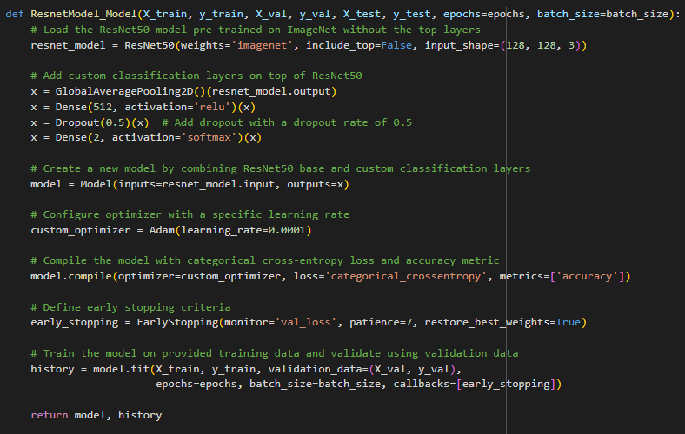Early Stopping: Monitored on validation loss with patience = 7*

Figure 18:ResNet50 Model Architecture.

* *Print and Plot Results:*
* *Results of each model for different durations are printed, including accuracy, F1 score, and loss for the training and validation phase.*
* *Training history for each model is plotted.*
* *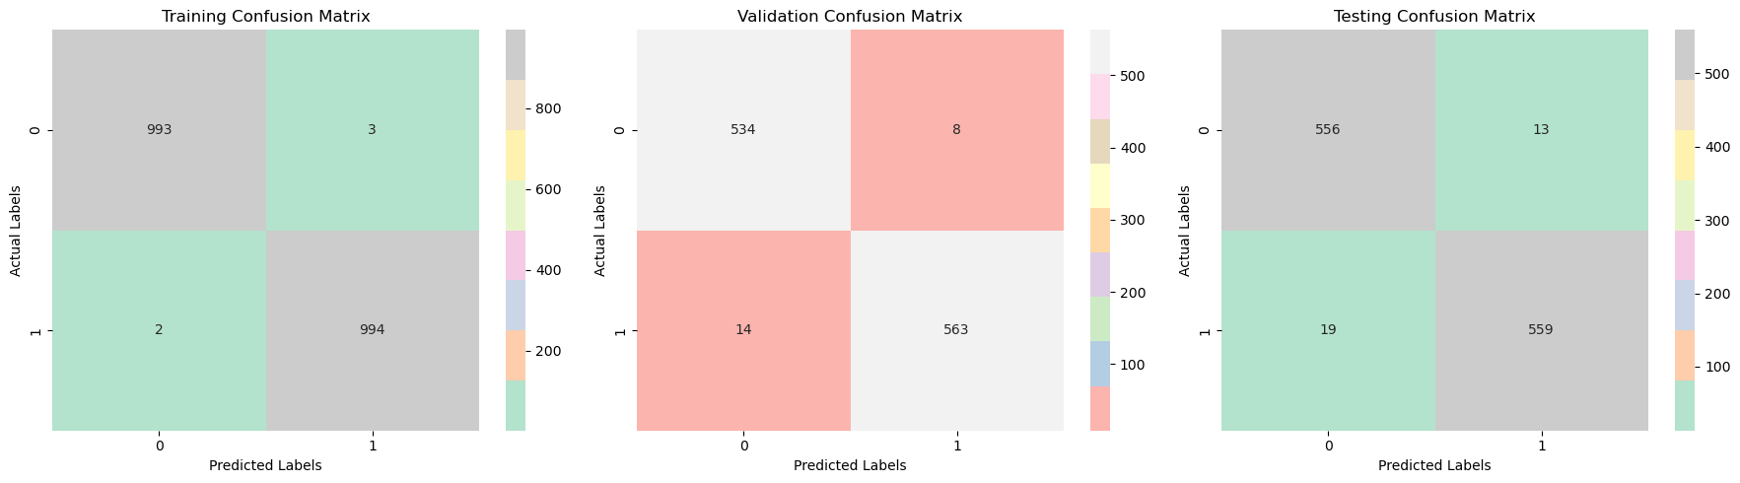One frame per 1 second*

Figure 19:Training and Validation Confusion Matrix for ResNet50 Model for 1-sec.

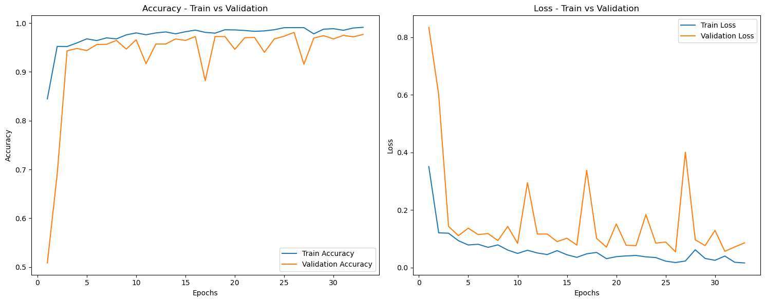

Figure 20:Learning and Loss Curve for ResNet50 Model for 1-sec.

* *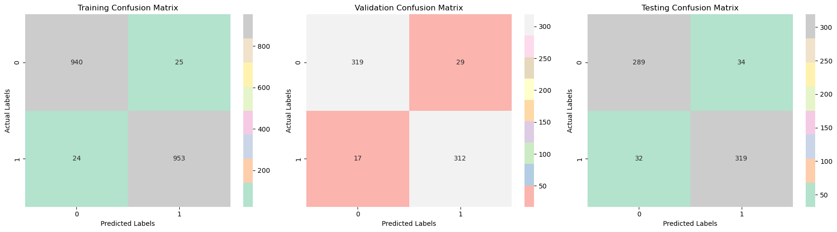One frame per 2 second*

Figure 21:Training and Validation Confusion Matrix for ResNet50 Model for 2-sec.

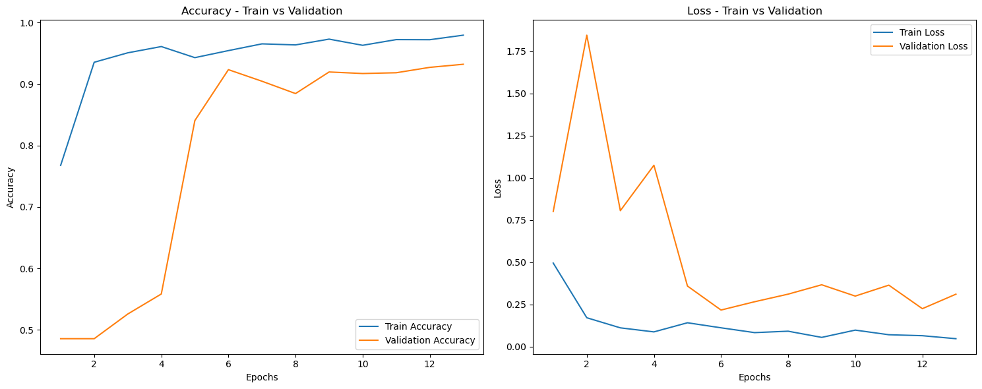

Figure 22:Learning and Loss Curve for ResNet50 Model for 2-sec.

* *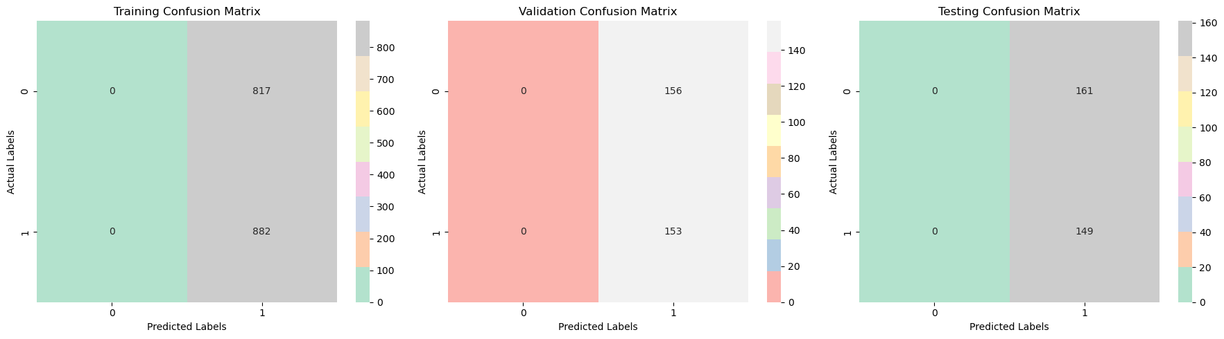One frame per 4 second*

Figure 23:Training and Validation Confusion Matrix for ResNet50 Model for 4-sec.

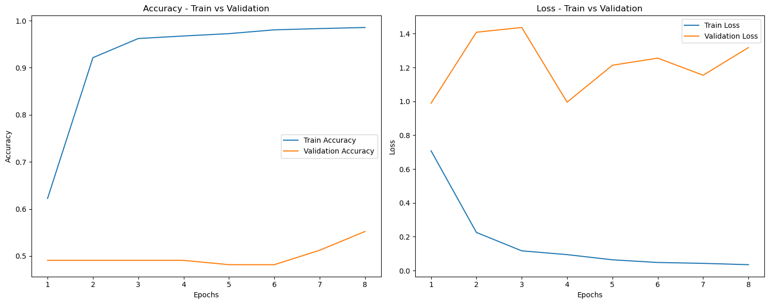

Figure 24:Learning and Loss Curve for ResNet50 Model for 4-sec.

* *InceptionResNetV2 Model (for 1sec, 2sec, and 4sec durations):*
* *Transfer Learning:*
* *Base Model: InceptionResNetV2 pre-trained on ImageNet*
* *Custom Layers:*
* *Global Average Pooling*
* *Dense Layer (512 units, ReLU activation, dropout rate = 0.5)*
* *Dense Layer (2 units, softmax activation)*
* *Model Compilation:*
* *Optimizer: Adam optimizer with ExponentialDecay (initial learning rate = 0.0001, decay steps = 10000, decay rate = 0.9)*
* *Loss Function: Categorical Cross-Entropy*
* *Training:*
* *Epochs: 100*
* *Batch Size: 32*
* *Learning Rate: ${10}^{-4}$*
* *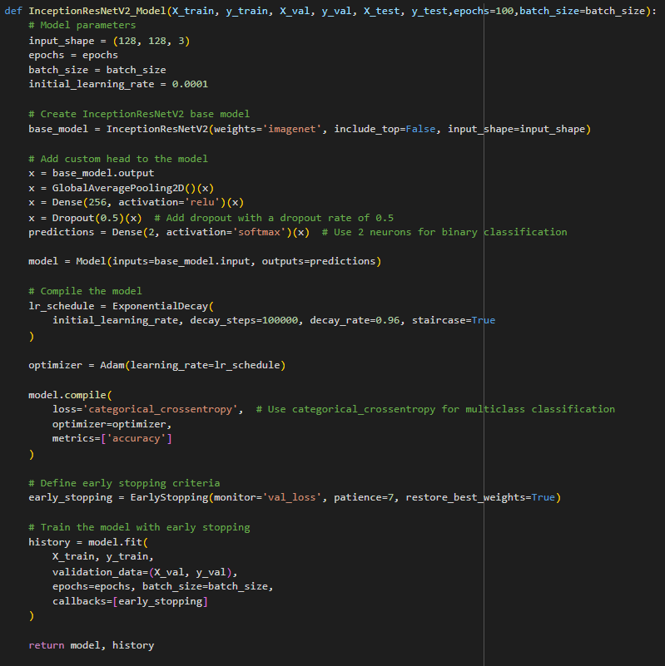Early Stopping: Monitored on validation loss with patience = 7*

Figure 25:InceptionResNetV2 Model Architecture.

* *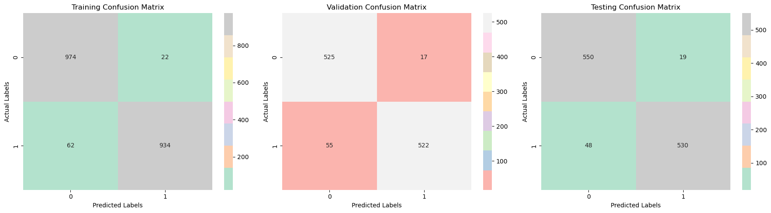One frame per 1 second*

Figure 26:Training and Validation Confusion Matrix for InceptionResNetV2 Model for 1-sec.

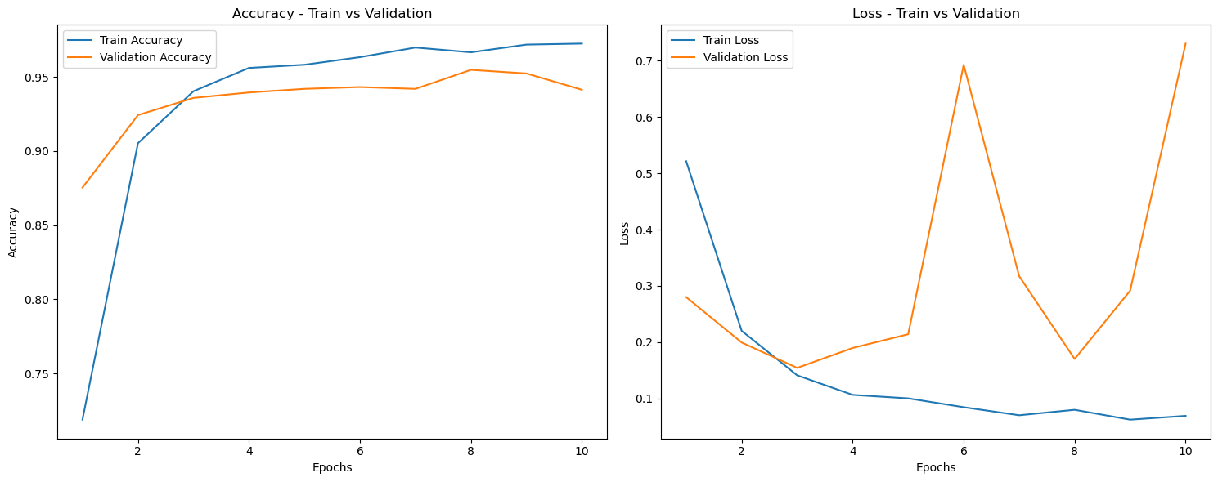

Figure 27:Learning and Loss Curve for InceptionResNetV2 Model for 1-sec.

* *One frame per 2 second*

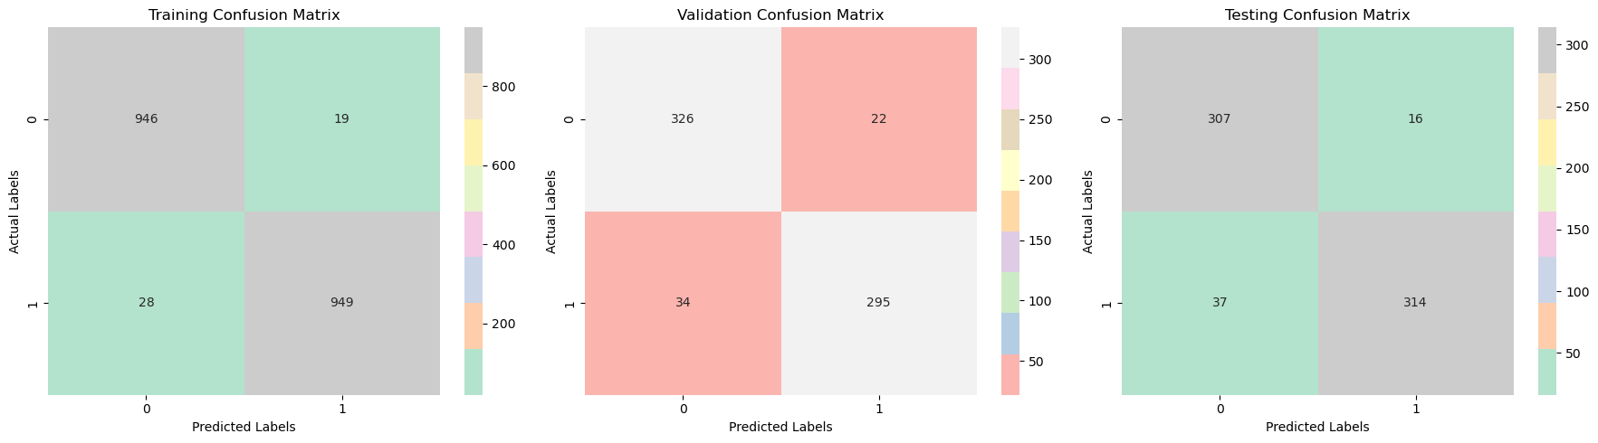

Figure 28:Training and Validation Confusion Matrix for InceptionResNetV2 Model for 2-sec.

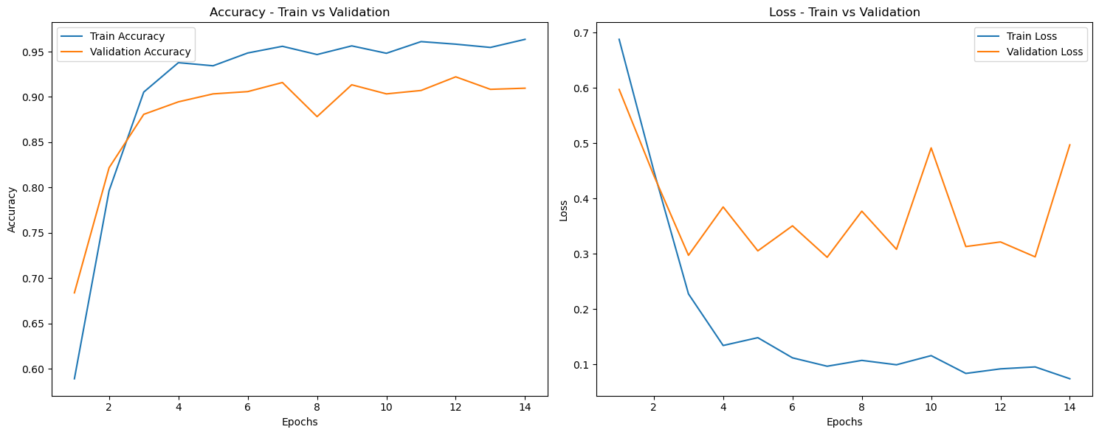

Figure 29:Learning and Loss Curve for InceptionResNetV2 Model for 2-sec.

* *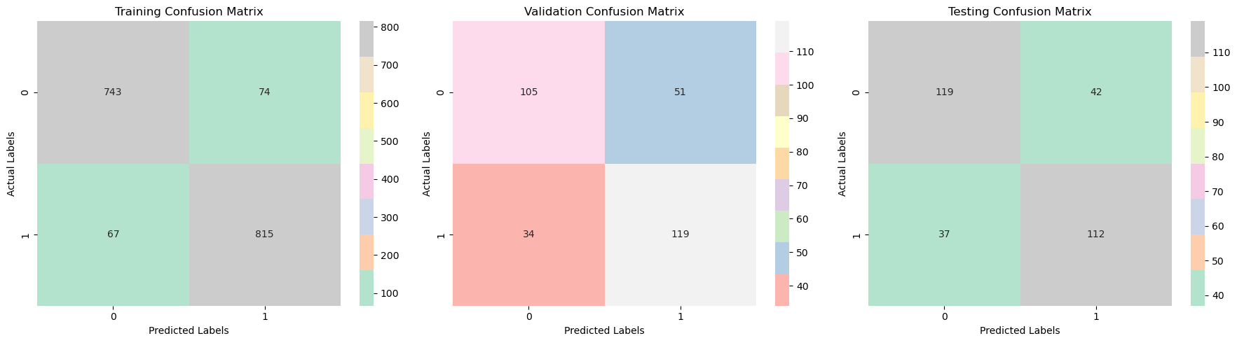One frame per 4 second*

Figure 30:Training and Validation Confusion Matrix for InceptionResNetV2 Model for 4-sec.

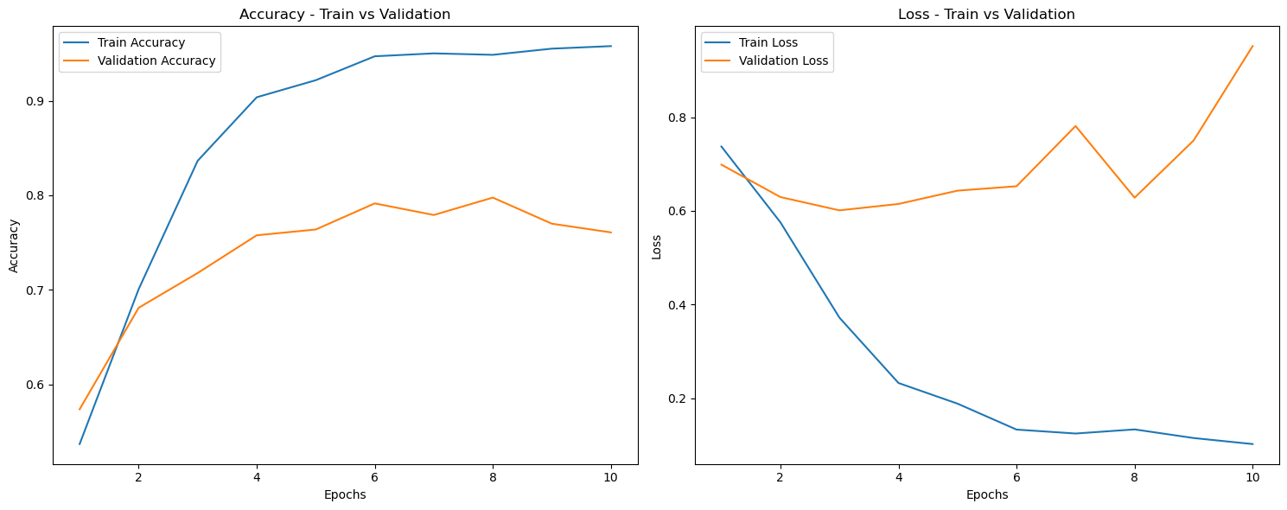

Figure 31:Learning and Loss Curve for InceptionResNetV2 Model for 4-sec.

* *MobileNetV2 Model (for 1sec, 2sec, and 4sec durations):*
* *Transfer Learning:*
* *Base Model: MobileNetV2 pre-trained on ImageNet*
* *Custom Layers:*
* *Global Average Pooling*
* *Dense Layer (512 units, ReLU activation, dropout rate = 0.5)*
* *Dense Layer (2 units, softmax activation)*
* *Model Compilation:*
* *Optimizer: Adam optimizer*
* *Learning Rate: 0.0001*
* *Loss Function: Categorical Cross-Entropy*
* *Training:*
* *Epochs: 100*
* *Batch Size: 32*
* *Learning Rate: ${10}^{-4}$*
* *Early Stopping: Monitored on validation loss with patience = 7*

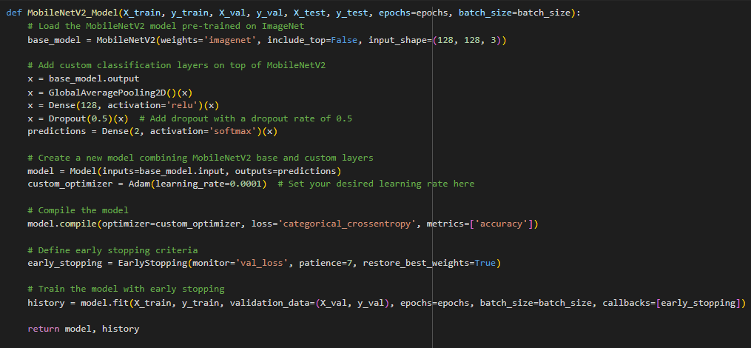

Figure 32:MobileNetV2 Model Architecture.

* *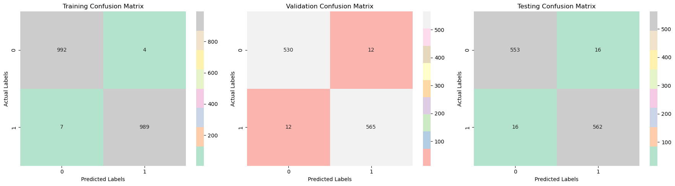One frame per 1 second*

Figure 33:Training and Valuation Confusion Matrix for MobileNetV2 Model for 1-sec.

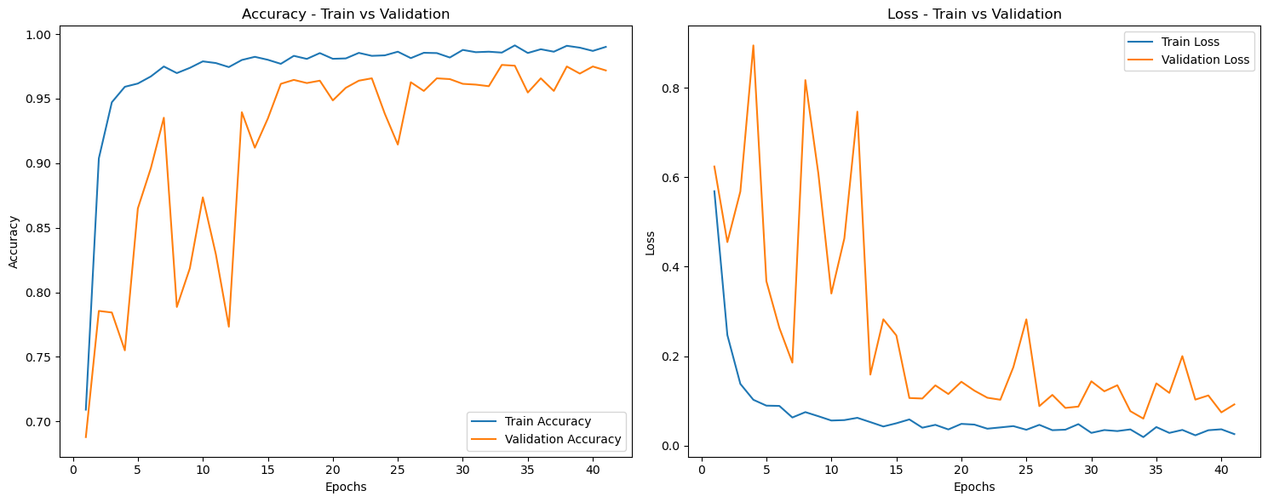

Figure 34: Learning and Loss Curve for MobileNetV2 Model for 1-sec.

* *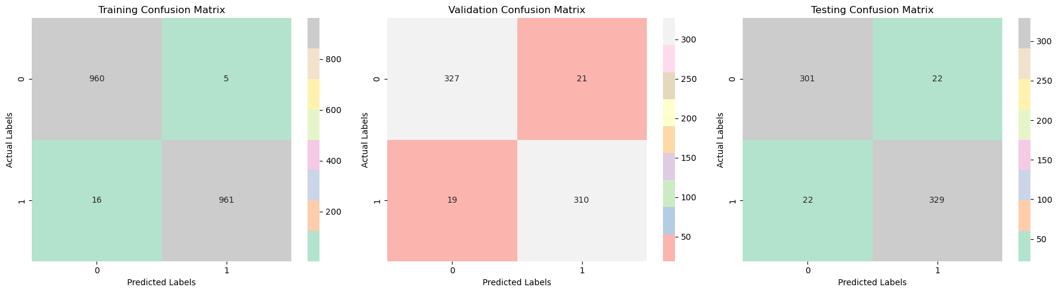One frame per 2 second*

Figure 35:Training and Validation Confusion Matrix for MobileNetV2 Model for 2-sec.

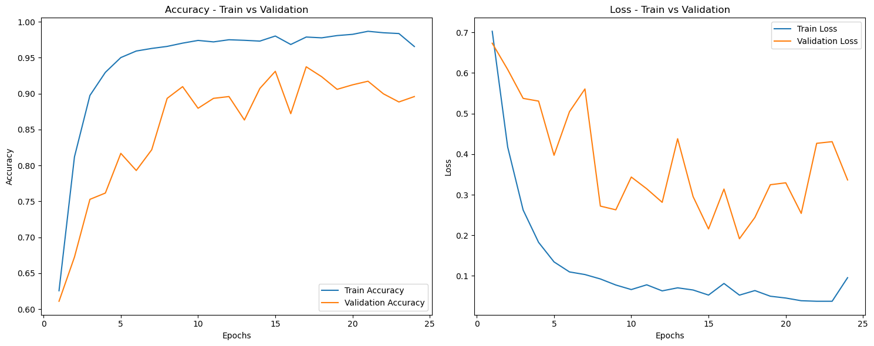

Figure 36:Learning and Loss Curve for MobileNetV2 Model for 2-sec.

* *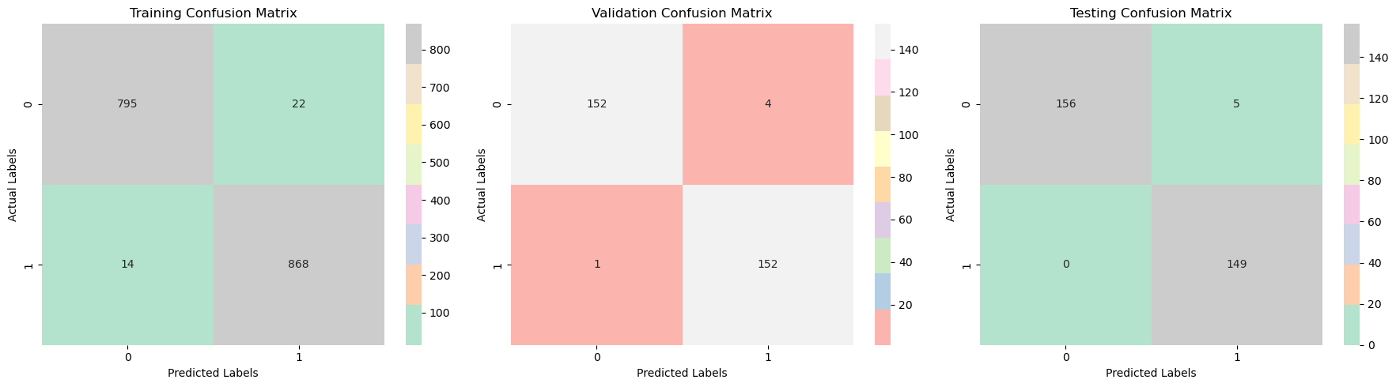One frame per 4 seconds*

Figure 37:Training and Validation Confusion Matrix for MobileNetV2 Model for 4-sec.

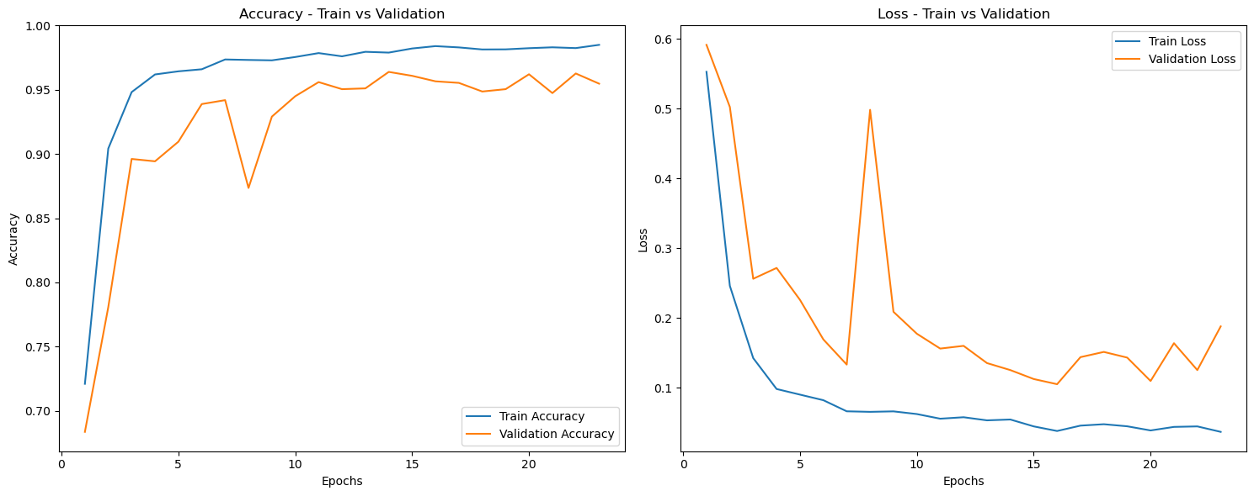

Figure 38:Learning and Loss Curve for MobileNetV2 Model for 4-sec.

* *VGG16 Transfer Model (for 1sec, 2sec, and 4sec durations):*
* *Transfer Learning:*
* *Base Model: VGG16 pre-trained on ImageNet*
* *Custom Layers:*
* *Global Average Pooling*
* *Dense Layer (512 units, ReLU activation, dropout rate = 0.5)*
* *Dense Layer (2 units, softmax activation)*
* *Model Compilation:*
* *Optimizer: Stochastic Gradient Descent (SGD) with learning rate = 0.001*
* *Loss Function: Categorical Cross-Entropy*
* *Training:*
* *Epochs: 100*
* *Batch Size: 32*
* *Learning Rate: ${10}^{-4}$*
* *Early Stopping: Monitored on validation loss with patience = 7*

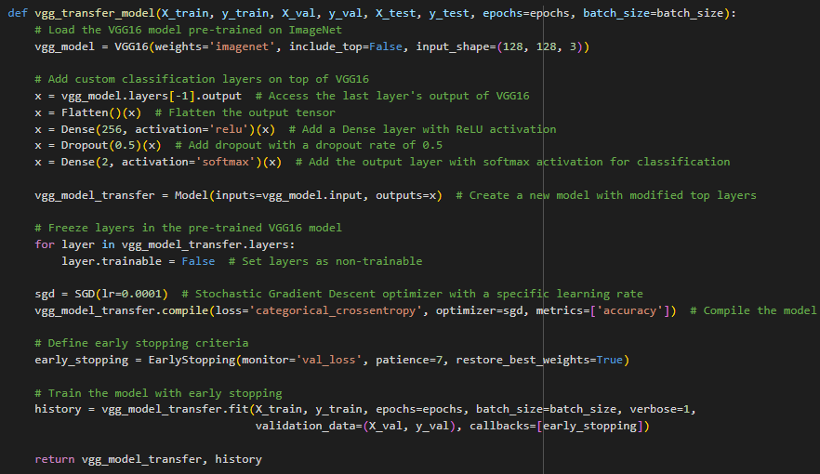

Figure 39:VGG16 Model Architecture

* *One frame per 1 second*

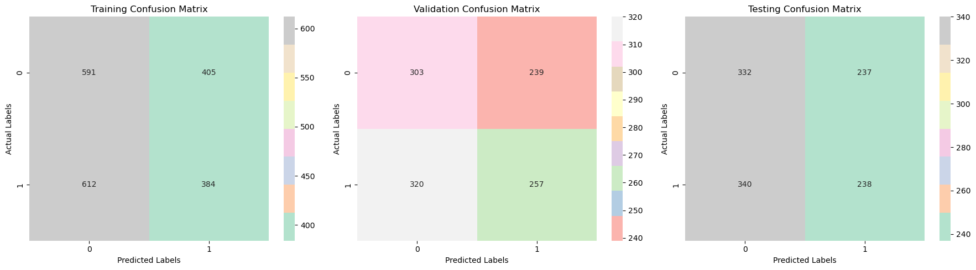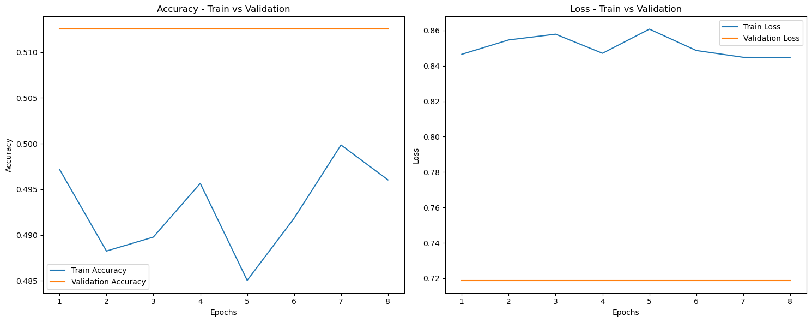

Figure 40:Training and Validation Confusion Matrix for VGG16 Model for 1-sec

Figure 41:Learning and Loss Curve for VGG16 Model for 1-sec.

* *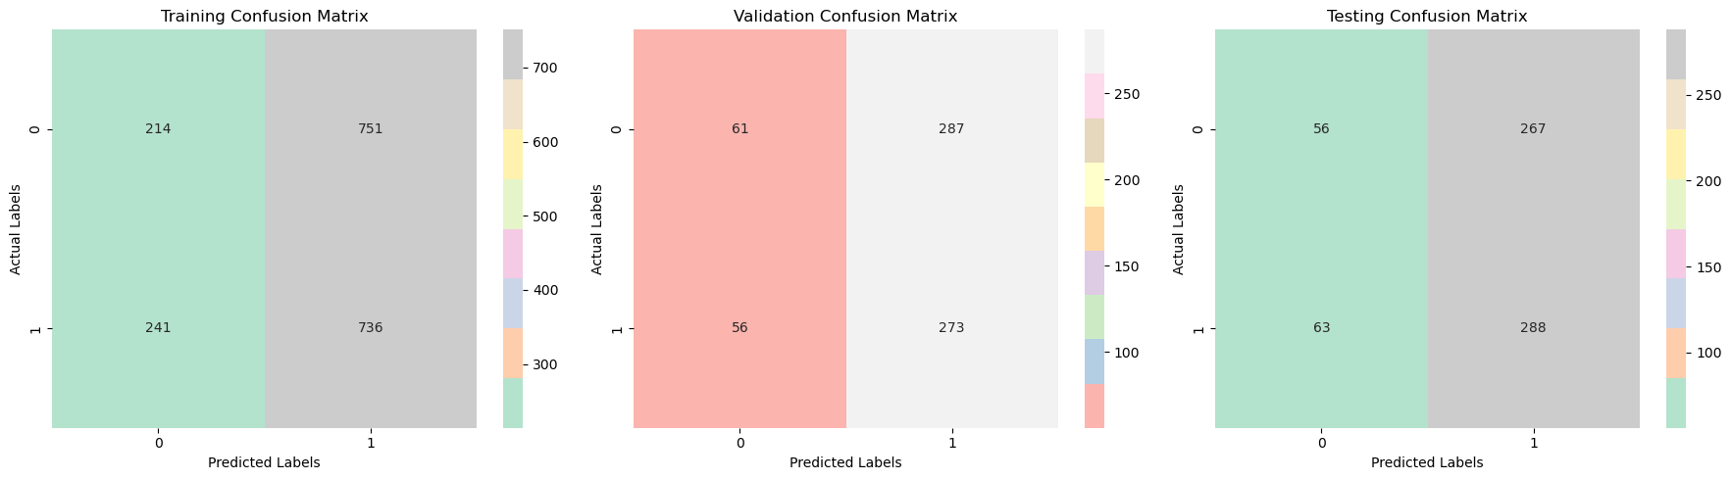One frame per 2 second*

Figure 42:Training and Validation Confusion Matrix for VGG16 Model for 2-sec.

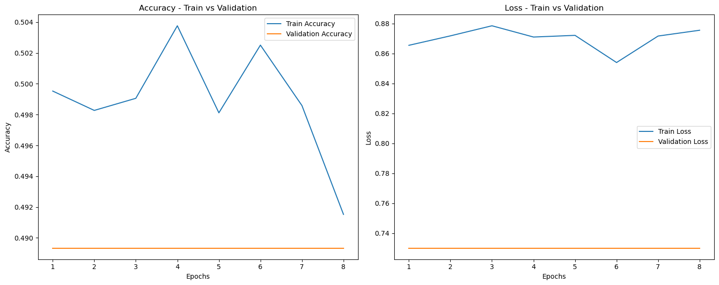

Figure 43:Learning and Loss Curve for VGG16 Model for 2-sec.

* *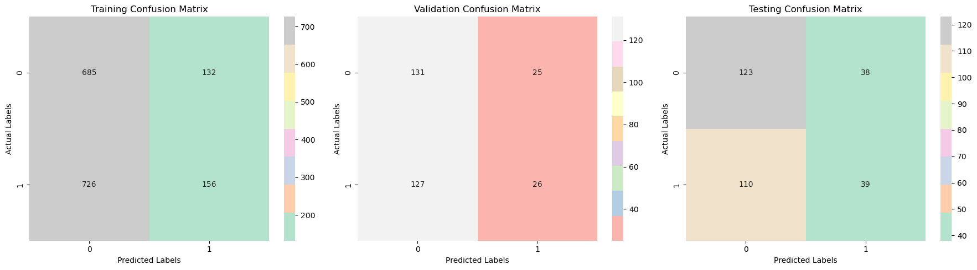One frame per 4 seconds*

Figure 44:Training and Validation Confusion Matrix for VGG16 Model for 4-sec.

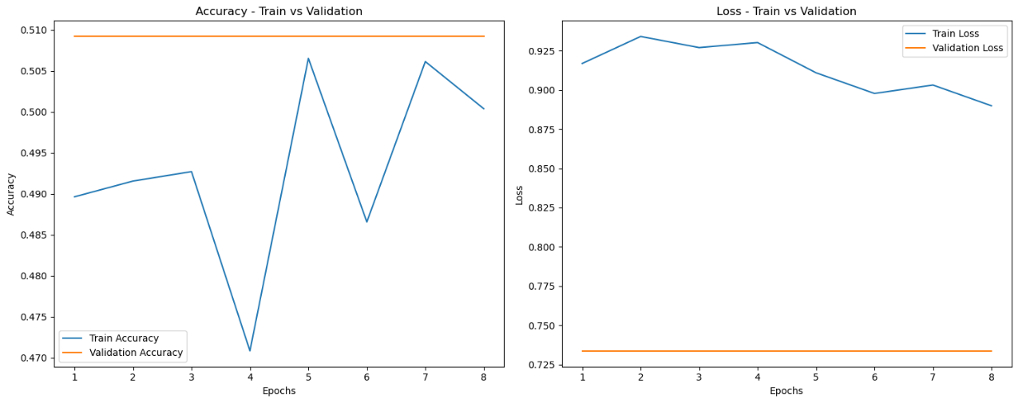

Figure 45:Learning and Loss Curve for VGG16 Model for 4-sec.

### ***Evaluation and Result Analysis*** *The confusion matrix is a fundamental tool in classification tasks, and it helps evaluate the performance of a model by providing a detailed breakdown of its predictions. In this case, the confusion matrix is calculated based on a specific threshold for determining the video label (REAL or FAKE) from the predicted frames. The process is outlined in the provided explanation:*

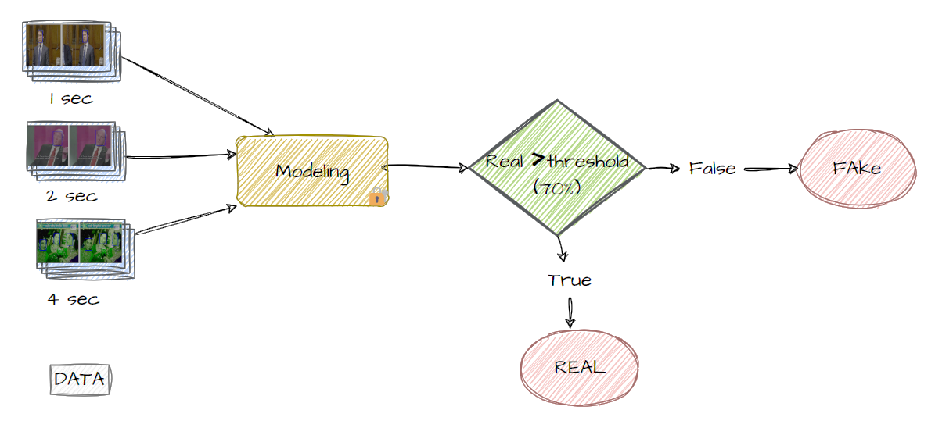

Figure 46:Evaluation Diagram Based on Video.

* *Prediction Threshold:*
* *The evaluation process primarily relies on counting the occurrence of the Real Label among the predicted frames for each video.*
* *If over 70% of the frames are predicted as REAL, the video is categorized as REAL; otherwise, it is classified as FAKE.*
* *Categorization of Videos:*
* *For each video, the model predicts a label based on the majority class of the frames. If more than 70% of the frames are predicted as REAL, the video is categorized as REAL; otherwise, it is categorized as FAKE.*
* *Comparison with Actual Labels:*
* *Subsequently, the predicted label obtained from the majority prediction of frames for each video is compared with the actual video label.*

*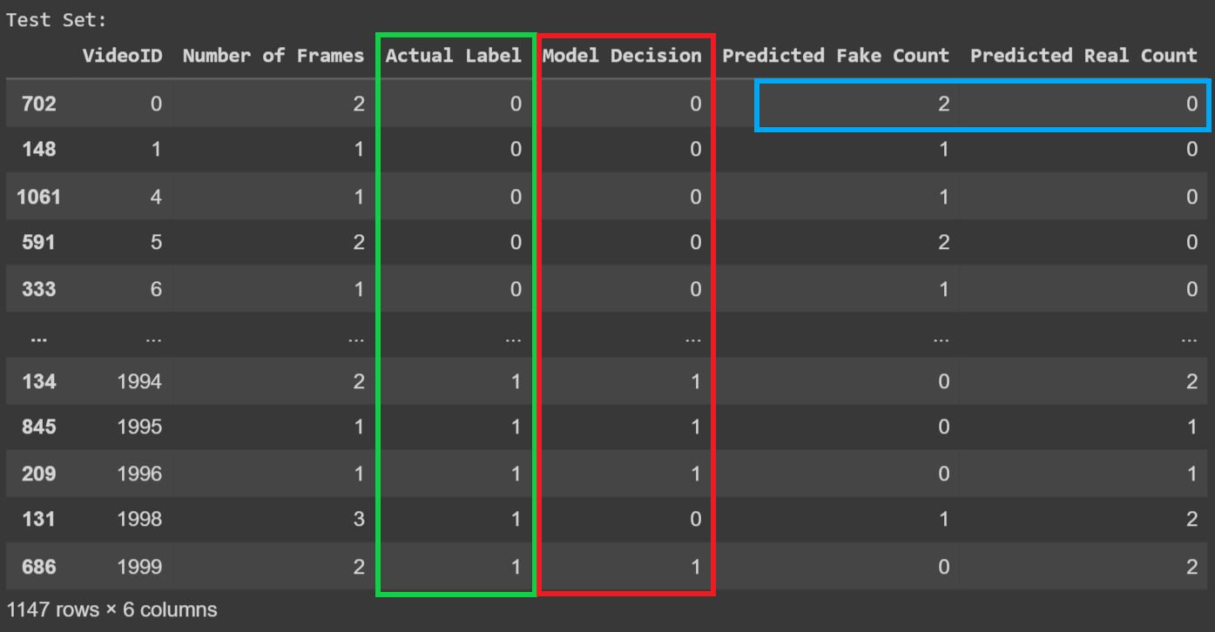  
Here is an example illustrating our evaluation process on the ResNetV2 model using the Test Set in one frame per 1 sec. The green column (Actual Label) contains the known actual labels of each video, while the red column (Model Decision) is derived from the two blue columns (Predicted Fake Count, Predicted Real Count).*

Figure 47:Example of ResNetV2 model using the Test Set in one frame per 1 sec for Evaluation.

* *F1 Score and Accuracy Calculation:*
* *The F1 score and accuracy are then calculated based on the comparison of predicted labels and actual labels. The F1 score is the harmonic mean of precision and recall, providing a balance between false positives and false negatives. Accuracy is the ratio of correctly predicted videos to the total number of videos.*
* *Learning and Loss Curve Based on Video:*
* *The learning curve and loss curve are based on video-level predictions and labels. These curves illustrate how the model's performance changes over training epochs concerning video-level metrics.*

|  |  |  |  |
| --- | --- | --- | --- |
| *Models || Duration* | *1sec* | *2sec* | *4sec* |
| *ResNetv2* | *Training: 99.7%*  *Validation: 98.1%* | *Training: 97.5%*  *Validation: 93.1%* | *Training: 68.3%*  *Validation: 66.2%* |
| *InceptionRestNetV2* | *Training: 95.7%*  *Validation: 93.5%* | *Training: 97.6%*  *Validation: 91.3%* | *Training: 92%*  *Validation: 73.7%* |
| *MobileNetV2* | *Training: 99.4%*  *Validation: 97.9%* | *Training: 98.9%*  *Validation: 93.9%* | *Training: 98%*  *Validation: 98.4%* |
| *VGG-16* | *Training: 43%*  *Validation: 47.9%* | *Training: 59.7%*  *Validation: 61.4%* | *Training: 26.6%*  *Validation: 25.5%* |

Table 1:Model Comparison in Training and Validation sets.

### ***Cross-Validation on the Champion Model*** *In ResNet50 Model, InceptionResNetV2, MobileNetV2 Model and VGG16 Transfer Model using F1-score in Test set.*

* *Model Selection for Cross-Validation:*
* *The model with the highest F1 score: MobileNetV2 was selected for cross-validation.*
* *Data Preparation for Cross-Validation:*
* *The training data is split into 5 folds, maintaining class distribution.*
* *Cross-Validation Loop:*
* *For each fold, the model is trained on a subset of the data and evaluated on the validation set.*
* *Performance Metrics Calculation:*
* *Accuracy and F1 score are calculated for each fold.*
* *Results Storage:*
* *Trained models, training history, accuracy, and F1 scores for each fold are stored.*
* *Average Metrics Calculation:*
* *Average accuracy and F1 score across all folds are calculated and printed.*

### ***Soft Voting on the Top 3 Models*** *In ResNet50 Model, InceptionResNetV2, MobileNetV2 Model using F1-score in Test set.*

* *Define Soft Voting:*
* *A function predicts probabilities for each model and averages them.*
* *Class labels are determined based on the average predictions.*
* *Prepare Test Data:*
* *Assign test data for the 1-second duration.*
* *Apply Soft Voting:*
* *Obtain predictions using soft voting for the best three models in 1 -second duration.*
* *ResNetV2*
* *InceptionResNetV2*
* *MobileNetV2*
* *Threshold for Binary Predictions:*
* *Set a threshold of 0.5.*
* *Convert predictions to binary (0 or 1) based on the threshold.*
* *Convert True Labels for Evaluation:*
* *Convert true labels to a NumPy array.*
* *Evaluate the Model:*
* *Calculate accuracy, precision, recall, and F1 score using scikit-learn metrics.*

### ***Hyperparameters Tuning on the Champion Model*** *Iin ResNet50 Model, InceptionResNetV2, MobileNetV2 Model and VGG16 Transfer Model using F1-score in Test set.*

* *Different Learning Rates: with batch size 32 and early stop after 5 epochs:*

*A learning rate is a hyperparameter that controls the step size during optimization. If the learning rate is too high, it might cause the model to overshoot the minimum; if it's too low, the model might converge very slowly or get stuck.*

* *Original Model: The MobileNetV2 model is trained with a learning rate of ${10}^{-4}$.*
* *First Modification: The learning rate is changed to ${10}^{-3}$ for a new training run.*
* *Second Modification: The learning rate is further modified to ${10}^{-5}$ for another training run.*
* *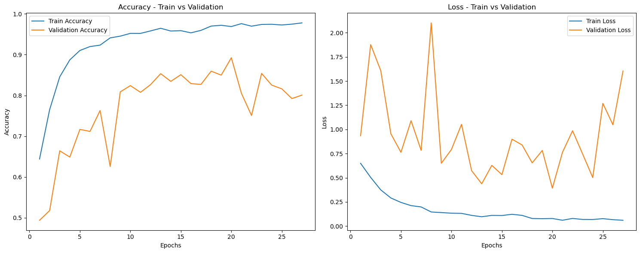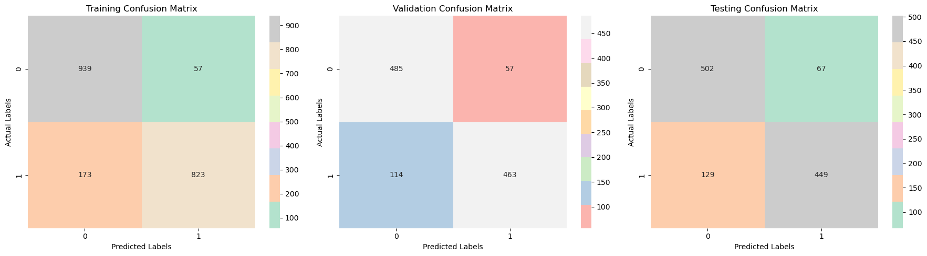 ${10}^{-3}$ on MobileNetV2 Model in 1 frame per 1 sec*

Figure 48:Training and Validation Confusion Matrix for MobileNetV2 Model for 1-sec with LR=10^-3.

Figure 49:Learn and Loss Curve for MobileNetV2 Model for 1-sec with LR=10^-3.

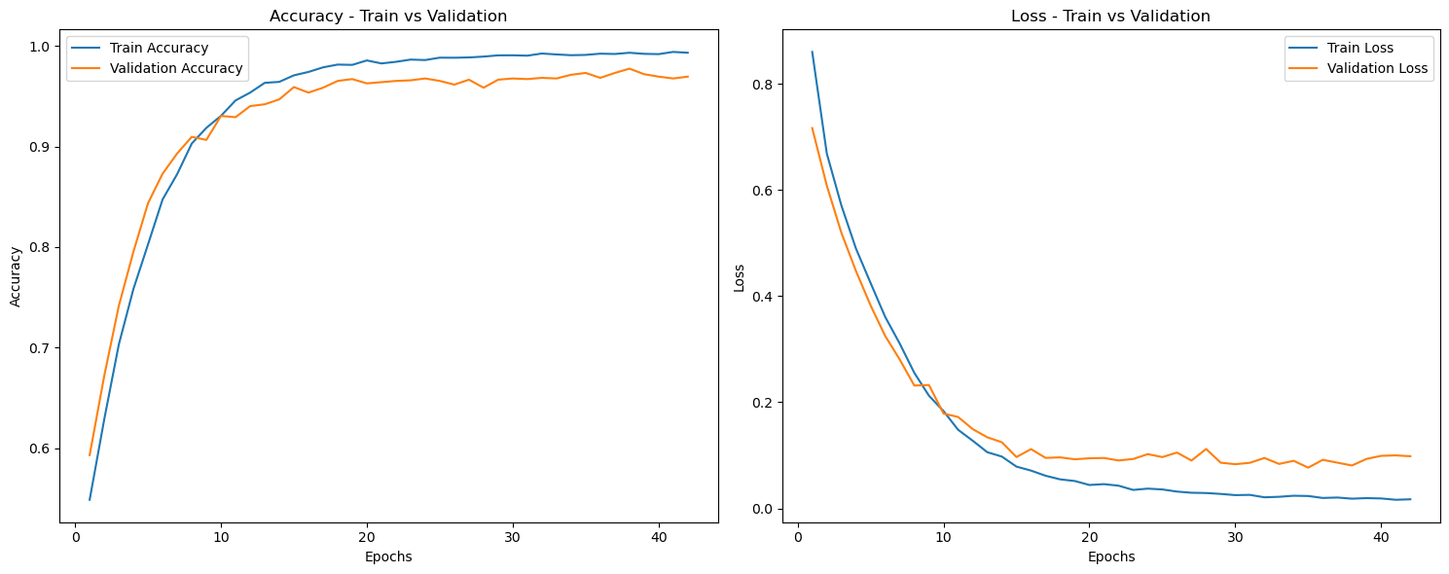

Figure 50:Training and Validation Confusion Matrix for MobileNetV2 Model for 1-sec with LR=10^-5.

Figure 51:Learn and Loss Curve for MobileNetV2 Model for 1-sec with LR=10^-5.

* ${10}^{-5}$*on MobileNetV2 Model in 1 frame per 1 sec*

|  |  |  |
| --- | --- | --- |
| *Sets || Learning Rate* | $${10}^{-3}$$ | $${10}^{-5}$$ |
| *Training* | *87.7%* | *99.3%* |
| *Validation* | *97.9%* | *96.5%* |

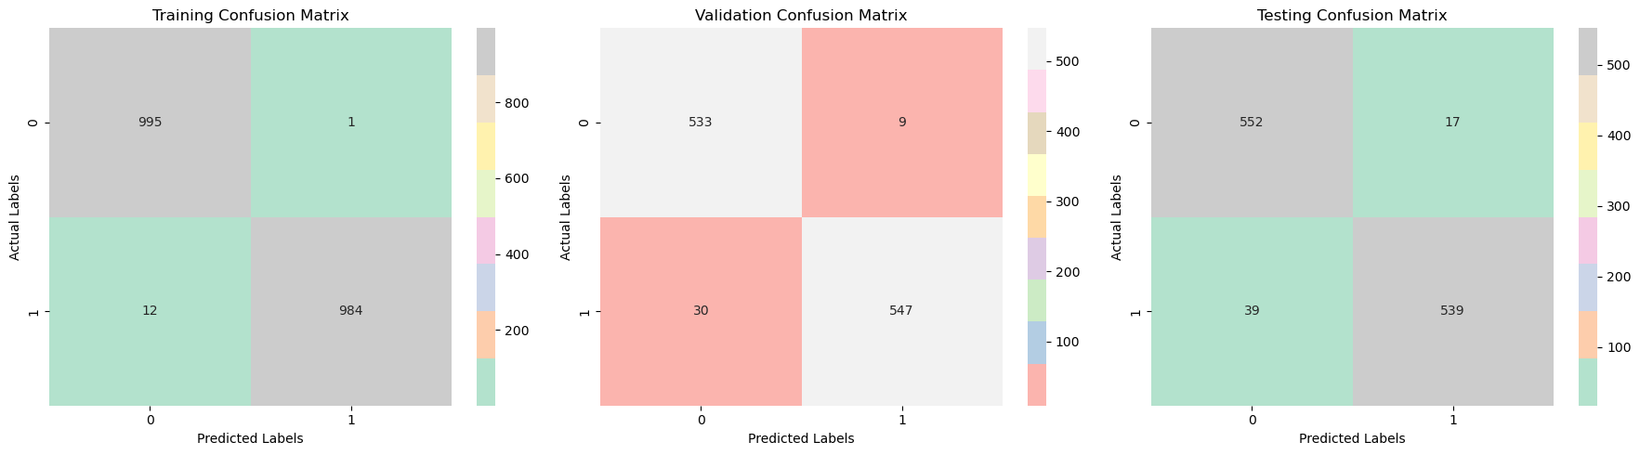

Table 2:Training and Validation F1-scores for Different Learning Rates.

* *Different Batch Sizes: with Learning Rate ${10}^{-4}$ and early stop after 5 epochs:*

*Batch size represents the number of training samples utilized in one iteration. Smaller batch sizes often lead to more noise in the training process, but they can converge faster. Larger batch sizes provide a smoother learning process but might take longer per epoch.*

* *Original Model: The MobileNetV2 model is trained with a batch size of 32.*
* *First Modification: The batch size is changed to 16 for a new training run.*
* *Second Modification: The batch size is changed to 64 for a new training run.*
* *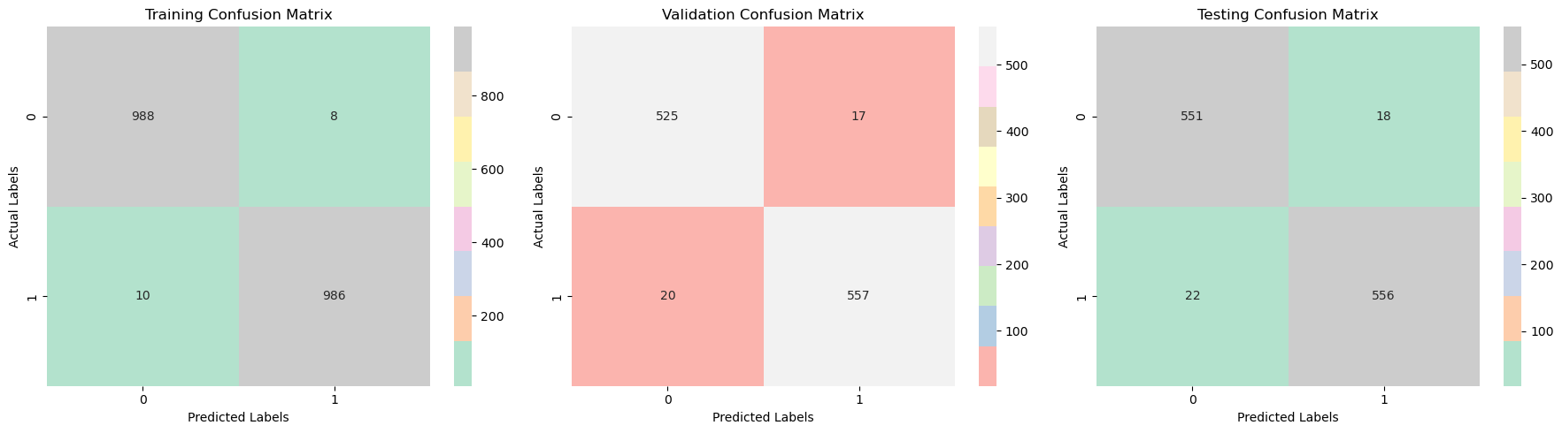16 on MobileNetV2 Model in 1 frame per 1 sec*

Figure 52:Training and Validation Confusion Matrix for MobileNetV2 Model for 1-sec with BS=16.

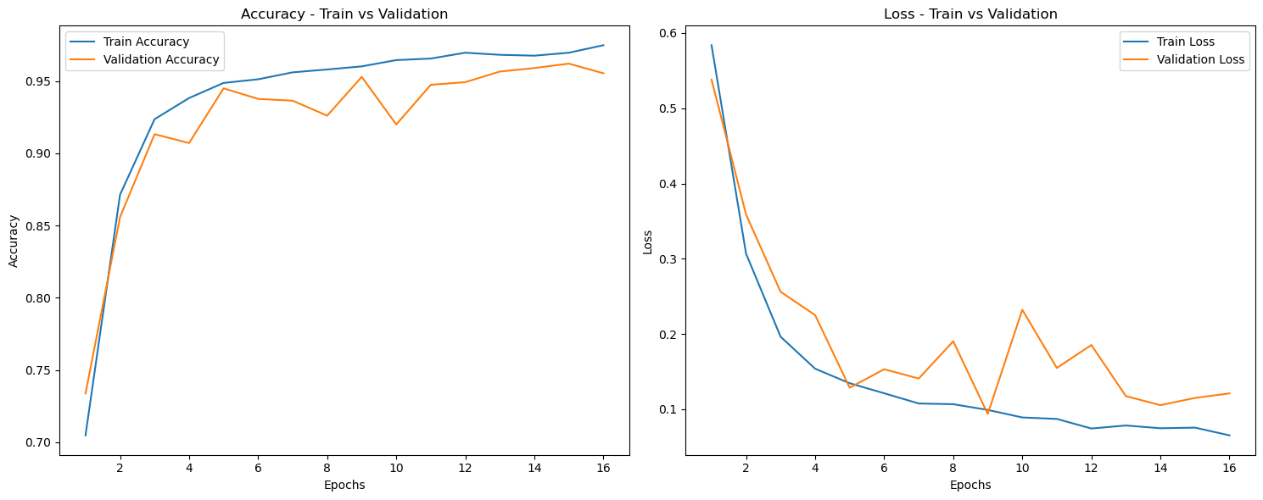

Figure 53: Learn and Loss Curve for MobileNetV2 Model for 1-sec with BS=16.

* *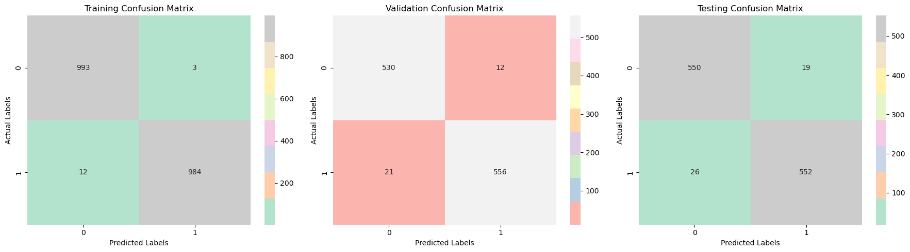64 on MobileNetV2 Model in 1 frame per 1 sec*

Figure 54:Training and Validation Confusion Matrix for MobileNetV2 Model for 1-sec with BS=64.

|  |  |  |
| --- | --- | --- |
| *Sets || Batch sizes* | *16* | *64* |
| *Training* | *99%* | *99.2%* |
| *Validation* | *96.8%* | *97.1%* |

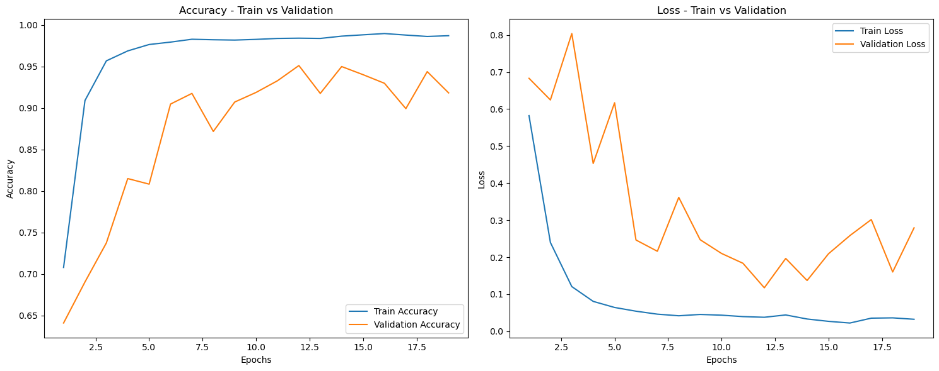

Figure 55:Learn and Loss Curve for MobileNetV2 Model for 1-sec with BS=64.

Table 3:Training and Validation F1-scores for Different Batch Sizes

* *Different number of epochs in early stop: with Learning Rate ${10}^{-4}$ and batch size =32:*

*Early stopping is a regularization technique to prevent overfitting. It stops training once a certain criterion (e.g., validation loss) stops improving.*

* *Original Model: Early stopping is set to restore the best weights after 7 epochs without improvement.*
* *Modification: The patience for early stopping is changed to 5 for another training run.*
* *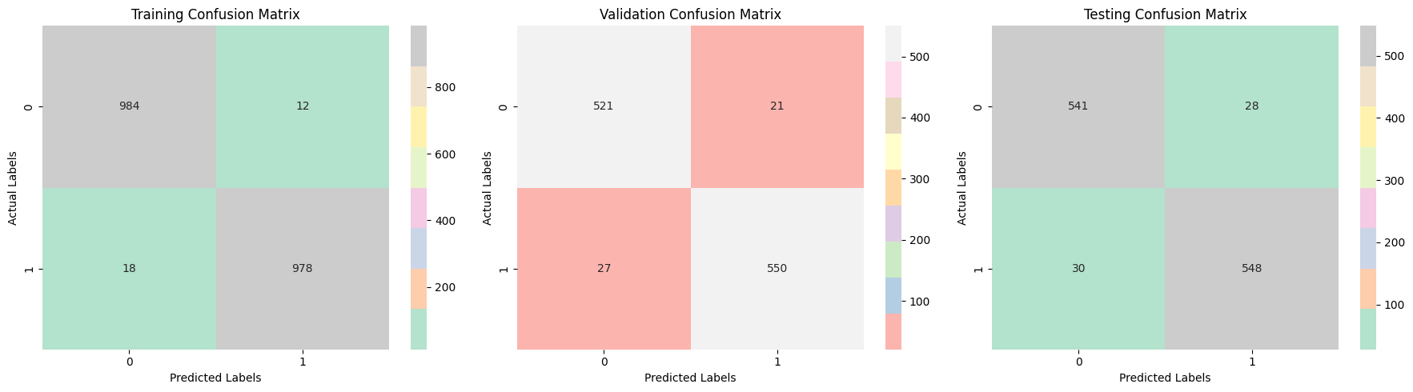 5 on MobileNetV2 Model in 1 frame per 1 sec*

Figure 56:Training and Validation Confusion Matrix for MobileNetV2 Model for 1-sec with Early stop=5.

|  |  |
| --- | --- |
| *Sets || Early Stop* | *5* |
| *Training* | *98.5%* |
| *Validation* | *95.8%* |

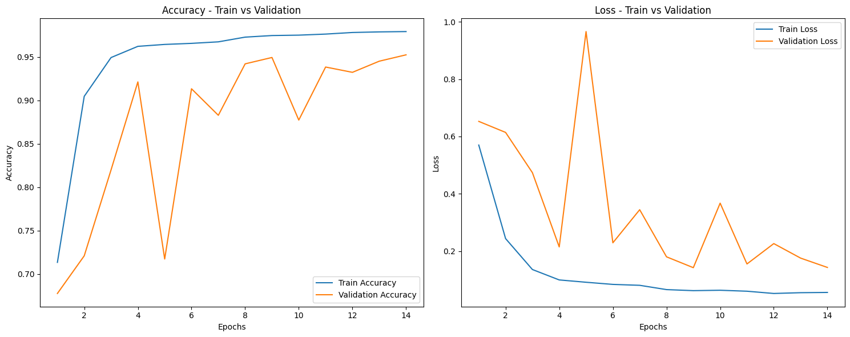

Figure 57:Learn and Loss Curve for MobileNetV2 Model for 1-sec with Early stop=5.

Table 4:Training and Validation F1-scores for Early Stop.

### ***Save the Superior Model: MobileNetV2***

* *Model and History Saving:*
* *Utilized the 'pickle' library for serializing and saving a MobileNetV2 model and its training history.*
* *Stored both the model and history in a dictionary (model_history_dict_MobileNetV2)*
* *File Writing:*
* *Employed the 'with open('MobileNetV2_model_history.pkl','wb') as file: context ' manager to write the serialized dictionary into a binary file.*
* *Loading Saved Model and History:*
* *Loaded the saved file using with open('MobileNetV2_model_history.pkl', 'rb') as file: in binary read mode.*
* *Assigned the loaded dictionary to 'loaded_model_history_dict_MobileNetV2'.*
* *Extraction of Model and History:*
* *Extracted the model and history from the loaded dictionary into variables: 'loaded_model_MobileNetV2' and' loaded_history_MobileNetV2'.*
* *Model Summary Display:*
* *Printed the summary of the loaded model using 'loaded_model_MobileNetV2.summary()'.*
* *History Inspection:*
* *Printed or inspected the loaded training history ('loaded_history_MobileNetV2'), offering insights into training metrics over epochs.*
* *Purpose:*
* *Facilitated convenient storage and retrieval of a trained MobileNetV2 model alongside its training history, enabling future use, sharing, or deployment.*
* *File Structure:*
* *The saved file ('MobileNetV2_model_history.pkl') encapsulates both the model and history in a serialized format, ensuring a comprehensive and self-contained storage.*
* *Usage:*
* *Enabled the reuse of the saved model and history for various purposes, including retraining, further analysis, or deployment in different environments.*

## ***2.4 Testing***

### ***2.4.1 Data Plan***

*The dataset used for the development of the deep fake video detection project is a comprehensive compilation of 2000 videos, with each video lasting between 8 to 13 seconds. This dataset is a combination of data contributed by our sponsor, subject to confidentiality agreements, and internally generated data using the ROOP Face Swap technique. The dataset is thoughtfully designed to include 1000 authentic videos and 1000 deep fake simulations as Showen in figure 58, creating a balanced dataset for robust model training and evaluation. The videos encompass a diverse range of subjects, including both celebrities and ordinary individuals, enhancing the dataset's realism and applicability.*

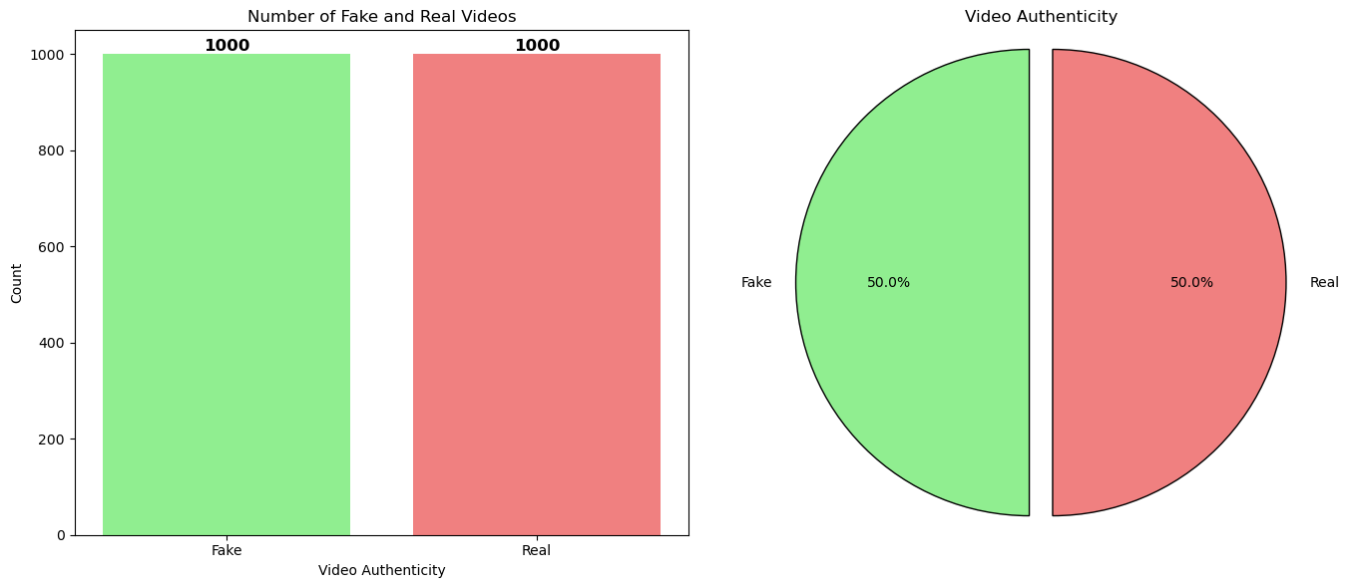

Figure 58:Number of Fake and Real Videos on the dataset.

*To ensure a representative and realistic synthetic dataset, the ROOP Face Swap technique involves swapping faces in videos with those extracted from photographs. The dataset's authenticity is maintained through in-depth discussions with the sponsor to understand their data and meticulous implementation of face swapping techniques. The dataset is divided into training (80%), testing (10%), and validation (10%) sets, facilitating comprehensive model assessment.*

*The inclusion of videos featuring both celebrities and regular people adds an extra layer of complexity and diversity to the dataset, enhancing the model's ability to detect deep fake scenarios across a broad spectrum of subjects. This dataset is made available for project development and testing, with a focus on realism, diversity, and consistency in video duration across all samples.*

### ***2.4.2 Validation & Verification***

1. *Model Comparison and Analysis*

* *Print and Plot Results:*
* *Results of each model for different durations are printed, including accuracy, F1 score, and loss for the training, validation, and Testing phase.*
* *Training history for each model is plotted.*
* *One frame per 1 second*
* *ResNet50 Model*

Figure 59:Testing Confusion Matrix for ReNet50 Model for 1-sec

* *InceptionResNetV2 Model*

Figure 60:Testing Confusion Matrix for InceptionResNet50 Model for 1-sec

* *MobileNetV2 Model*

Figure 61:Testing Confusion Matrix for MobileNetV2 Model for 1-sec.

* *VGG16 Transfer Model*
* 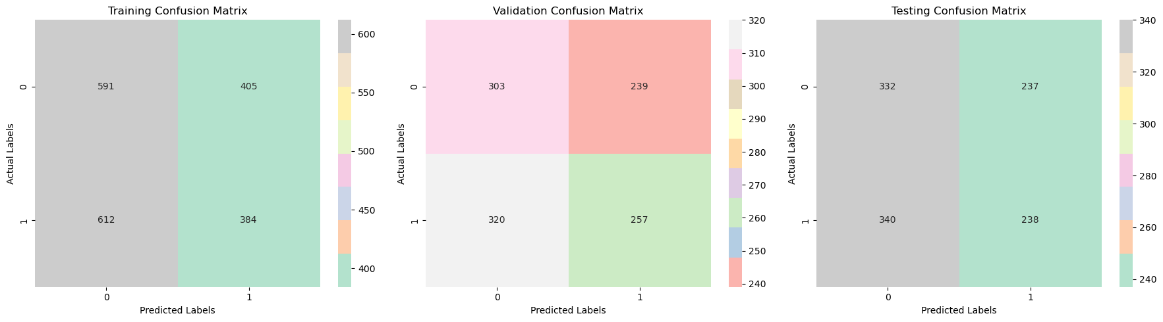 *- One frame per 2 second*

Figure 62:Testing Confusion Matrix for VGG16 Model for 1-sec.

* *ResNet50 Model*

Figure 63:Testing Confusion Matrix for ReNet50 Model for 2-sec.

* *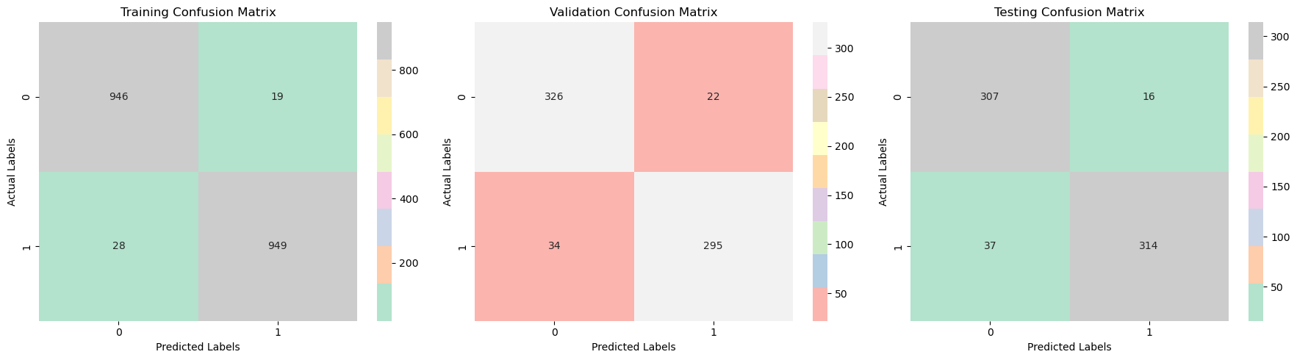InceptionResNetV2 Model*

Figure 64:Testing Confusion Matrix for InceptionReNet50 Model for 2-sec.

* *MobileNetV2 Model*

Figure 65:Testing Confusion Matrix for MobileNetV2 Model for 2-sec.

* *VGG16 Transfer Model*

Figure 66:Testing Confusion Matrix for VGG16 Model for 2-sec.

* *One frame per 4 second*
* *ResNet50 Model*

Figure 67:Testing Confusion Matrix for ReNet50 Model for 4-sec

* 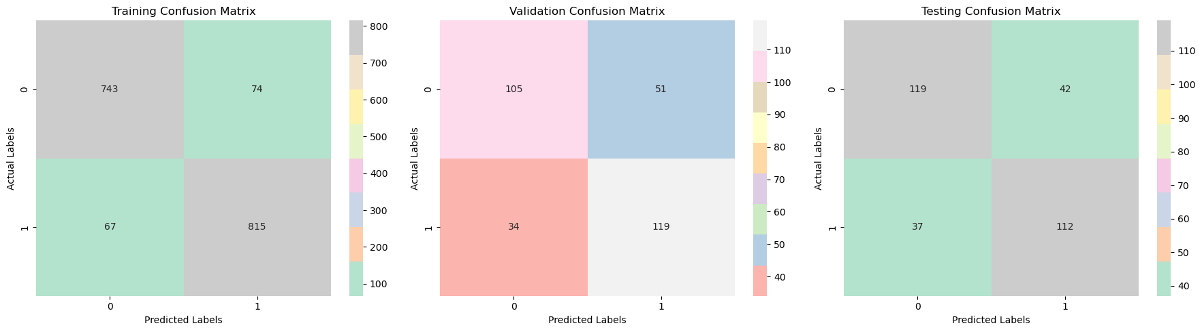*InceptionResNetV2 Model**MobileNetV2 Model*

Figure 68:Testing Confusion Matrix for InceptionReNet50 Model for 4-sec

Figure 69:Testing Confusion Matrix for MobileNetV2 Model for 4-sec.

* *VGG16 Transfer Model*

**

Figure 70:Testing Confusion Matrix for VGG16 Model for 4-sec.

Table 5:Model Comparison in Training and Validation sets.

|  |  |  |  |
| --- | --- | --- | --- |
| *Models || Duration* | *1sec* | *2sec* | *4sec* |
| *ResNetv2* | *97.217%* | *90.6%* | *64.9%* |
| *InceptionRestNetV2* | *94%* | *92.2%* | *73.9%* |
| *MobileNetV2* | *97.231%* | *93.7%* | *98.3%* |
| *VGG-16* | *45.2%* | *63.6%* | *34.5%* |

1. 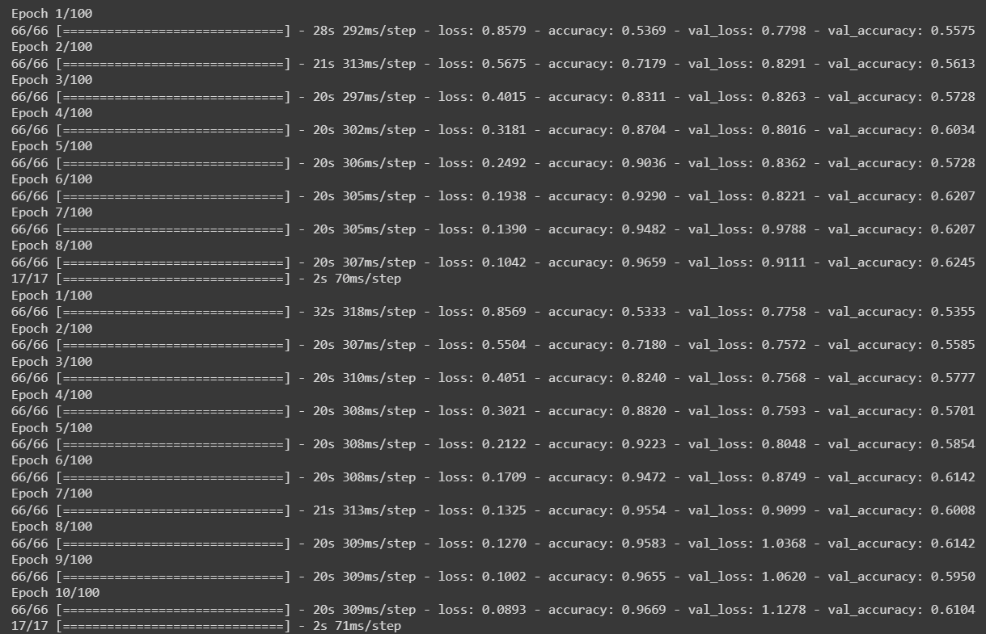 *Cross-Validation on the Champion Model: MobileNetV2 Model in the 1 Frame per 1 sec.*

Figure 71:Snapshot from Running MobileNetV2 Model after applying Cross-Validation.

1. *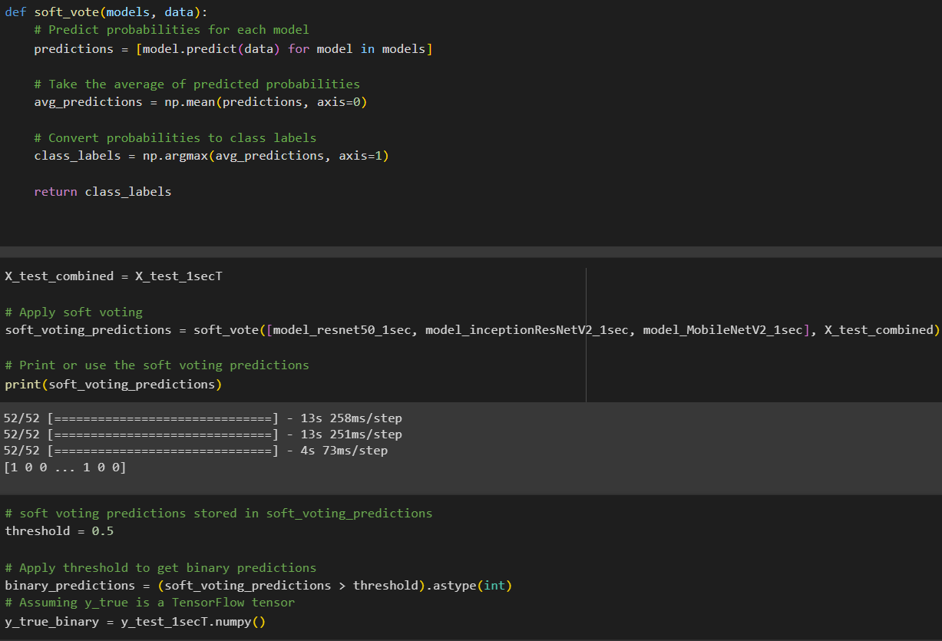Soft Voting on the 3 Top Models: ResNet50 Model, InceptionResNetV2, MobileNetV2 Model in the 1 Frame per 1 sec.*

Figure 72:Snapshot from code for applying Sof Voting using ResNet50 Model, InceptionResNetV2, MobileNetV2 Model

1. *Hyperparameters Tuning: in MobileNetV2 Model in the 1 Frame per 1 sec.*

* *Different Learning Rates: with batch size 32 and early stop after 5 epochs*

Figure 73:Testing Confusion Matrix for MobileNetV2 Model for 1-sec with LR=10^-3.

* ${10}^{-3}$*on MobileNetV2 Model in 1 frame per 1 sec*



Figure 74:Testing Confusion Matrix for MobileNetV2 Model for 1-sec with LR=10^-5.

* ${10}^{-5}$*on MobileNetV2 Model in 1 frame per 1 sec*

Table 6:Testing f1-scorce for Different Learning Rate.

|  |  |  |
| --- | --- | --- |
| *Sets || Learning Rate* | $${10}^{-3}$$ | $${10}^{-5}$$ |
| *Testing* | *82.1%* | *95.1%* |

* *Different Batch Sizes: with Learning Rate ${10}^{-4}$ and early stop after 5 epochs*
* *16 on MobileNetV2 Model in 1 frame per 1 se*

Figure 75:Testing Confusion Matrix for MobileNetV2 Model for 1-sec with BS=16.

* *64 on MobileNetV2 Model in 1 frame per 1 sec*

Figure 76:Testing Confusion Matrix for MobileNetV2 Model for 1-sec with BS=64.

|  |  |  |
| --- | --- | --- |
| *Sets || Batch sizes* | *16* | *64* |
| *Testing* | *96.5%* | *96.1%* |

Table 7:Testing f1-scorce for Different Batch sizes.

* *Different number of epochs in early stop: with Learning Rate ${10}^{-4}$ and batch size =32*
* *5 on MobileNetV2 Model in 1 frame per 1 sec*

Figure 77:Testing Confusion Matrix for MobileNetV2 Model for 1-sec with Early Stop=5.

Table 8:Testing f1-scorce with early stop=5.

|  |  |
| --- | --- |
| *Sets || Early Stop* | *5* |
| *Testing* | *95%* |

# 

# 3. Overall Results and Analysis

1. *F1 Score Comparison:*

* *F1 Score Collection:*

|  |  |  |  |
| --- | --- | --- | --- |
| *Models || Duration* | *1sec* | *2sec* | *4sec* |
| *ResNetv2* | *Training: 99.7%*  *Validation: 98.1%*  *Testing: 97.217%* | *Training: 97.5%*  *Validation: 93.1%*  *Testing: 90.6%* | *Training: 68.3%*  *Validation: 66.2%*  *Testing: 64.9%* |
| *InceptionRestNetV2* | *Training: 95.7%*  *Validation: 93.5%*  *Testing: 94%* | *Training: 97.6%*  *Validation: 91.3%*  *Testing: 92.2%* | *Training: 92%*  *Validation: 73.7%*  *Testing: 73.9%* |
| *MobileNetV2* | *Training: 99.4%*  *Validation: 97.9%*  *Testing: 97.231%* | *Training: 98.9%*  *Validation: 93.9%*  *Testing: 93.7%* | *Training: 98%*  *Validation: 98.4%*  *Testing: 98.3%* |
| *VGG-16* | *Training: 43%*  *Validation: 47.9%*  *Testing: 45.2%* | *Training: 59.7%*  *Validation: 61.4%*  *Testing: 63.6%* | *Training: 26.6%*  *Validation: 25.5%*  *Testing: 34.5%* |

*The F1 scores of each model for the train ,valid and test sets are collected and stored.*

Table 9:Overall Performance using F1-score.

* *1-Second Superiority*

*Selecting a One frame per 1-second duration for video processing is recommended due to its consistent high training and validation accuracy across different models (ResNetV2, InceptionResNetV2, MobileNetV2, VGG-16). This duration strikes a balance between capturing essential temporal information, ensuring better generalization, and reducing computational load for improved efficiency in training and inference.*

* *Champion Model Identification:*
* *The model with the highest F1 score : MobileNetV2 in One frame per 1 sec.*

*<function keras.src.applications.mobilenet_v2.MobileNetV2(input_shape=None, alpha=1.0, include_top=True, weights='imagenet', input_tensor=None, pooling=None, classes=1000, classifier_activation='softmax', **kwargs)>*

* *The actual model corresponding to the champion is assigned to champion_model for further analysis.*

*Insights:*

* *ResNetV2:*
* *Demonstrates strong performance for 1-second duration in training and validation but experiences a significant drop in accuracy for longer durations, suggesting potential challenges in capturing temporal dependencies over extended time frames.*
* *InceptionResNetV2:*
* *Consistently performs well across all durations in training and testing. However, there is a noticeable decline in validation accuracy for longer durations, indicating potential overfitting or difficulty generalizing to unseen data.*
* *MobileNetV2:*
* *Maintains high accuracy across all durations in both training and testing, showing robustness to variations in video length. This could be attributed to MobileNetV2's efficiency in handling diverse video content.*
* *VGG-16:*
* *Struggles to capture meaningful features for video classification, resulting in lower accuracy across all durations. VGG-16 might be insufficient for learning temporal patterns in video data compared to more advanced architectures like ResNetV2 and InceptionResNetV2.*

*General Observations:*

* *The performance drop for longer video durations across models suggests the need for improved methods to capture temporal dependencies in videos, potentially through more advanced architectures or temporal modeling techniques.*
* *Consistent high accuracy in training but lower accuracy in validation/testing for some models may indicate overfitting, emphasizing the importance of regularization techniques.*
* *MobileNetV2 stands out for its consistent high performance across different video durations, highlighting its suitability for video classification tasks with varying temporal contexts.*

1. *Cross- Validation on the Champion Model: MobileNetV2 Model in the 1 Frame per 1 sec.*

* *Performance Metrics Calculation:*
* *Accuracy and F1 score are calculated for each fold.*
* *Results Storage:*
* *Trained models, training history, accuracy, and F1 scores for each fold are stored.*
* *Average Metrics Calculation:*
* *Average accuracy and F1 score across all folds are calculated and printed.*

Table 10:Average Metrics Calculation for Cross Validation.

|  |  |
| --- | --- |
| *Fold 5 - Accuracy* | *54.89%* |
| *Average F1-scorce* | *54.89%* |
| *Average Accuracy* | *54.89%* |

*Insights:*

*The observed low average F1 score in cross-validation could be influenced by various factors.*

* *Imbalanced Data Distribution:*
* *Cross-validation may expose the model to imbalanced class distributions in some folds. If certain folds have significantly fewer instances of one class, it can impact F1 score, which considers both precision and recall.*
* *Model Sensitivity to Specific Data Splits:*
* *Some models may be sensitive to the specific data split in cross-validation. If certain folds contain challenging examples that the model struggles with, it can result in lower F1 scores.*
* *Overfitting or Underfitting:*
* *The model might be overfitting or underfitting to the training data in some folds. Overfitting can lead to poor generalization, while underfitting may result in inadequate learning.*
* *Hyperparameter Sensitivity:*
* *Sensitivity to the chosen hyperparameters might impact model performance in certain folds. Hyperparameters that are well-suited to one subset of the data may not generalize optimally to other subsets.*
* *Limited Data:*
* *The limited amount of data in each fold could contribute to variability in performance. With a small amount of data, the model might struggle to learn complex patterns effectively.*
* *Noise in Labels:*
* *If there is noise in the labels or if some samples are mislabeled, it can affect the model's ability to learn and generalize.*

1. *Soft Voting on the 3 Top Models: ResNet50 Model, InceptionResNetV2, MobileNetV2 Model in the 1 Frame per 1 sec.*

* *Evaluate the Model:*
* *Calculate accuracy, precision, recall, and F1 score using scikit-learn metrics.*

Table 11:Metrics Calculation in Soft Voting.

|  |  |
| --- | --- |
| *F1 Score* | *97.149%* |
| *Accuracy* | *97.128%* |
| *Recall* | *97.7%* |
| *Precision* | *96.6%* |

*Insights:*

*The achieved F1 score of 97.149% can be attributed to several factors:*

* *Effective Ensemble Learning:*
* *Soft voting combines predictions from multiple models (ResNetV2, InceptionResNetV2, MobileNetV2). If one model makes a mistake, others may compensate, contributing to the overall robustness of predictions.*
* *Diversity in Model Architectures:*
* *The selected models (ResNetV2, InceptionResNetV2, MobileNetV2) have different architectures and were likely trained on diverse features, capturing various patterns in the data. Combining these diverse features through ensemble learning can improve the overall model performance.*
* *Probabilistic Averaging:*
* *Soft voting considers the probabilities predicted by each model and averages them. This approach considers the confidence of each model in its predictions. Averaging probabilities can smooth out individual model errors and provide more reliable predictions.*
* *Optimal Threshold Selection:*
* *The chosen threshold of 0.5 for converting probabilities to binary predictions is suitable for the task. It represents the balance point where predictions are categorized as one class or the other. The threshold might have been selected based on the characteristics of the dataset and the desired trade-off between precision and recall.*
* *Quality of Training Data:*
* *The quality and representativeness of the training data play a crucial role. If the models were trained on a diverse and well-labeled dataset that accurately represents the real-world scenarios, they are more likely to generalize well to unseen data.*
* *Balanced Evaluation Metrics:*
* *F1 score is a balanced metric that considers both precision and recall. Achieving a high F1 score indicates that the model performs well in correctly identifying both positive and negative instances, minimizing false positives and false negatives.*
* *Careful Model Selection:*
* *The choice of models used in the ensemble is essential. ResNetV2, InceptionResNetV2, and MobileNetV2 are known for their performance in image-related tasks, and their combination can lead to a strong video classification model.*

1. *Hyperparameters Tuning: in MobileNetV2 Model in the 1 Frame per 1 sec.*

* *Different Learning Rates: with batch size 32 and early stop after 5 epochs*

Table 12:Different Learning Rates F1-scores.

|  |  |  |  |
| --- | --- | --- | --- |
| *Sets || Learning Rate* | $${10}^{-3}$$ | $${10}^{-4}$$ | $${10}^{-5}$$ |
| *Training* | *87.7%* | *99.4%* | *99.3%* |
| *Validation* | *97.9%* | *97.9%* | *96.5%* |
| *Testing* | *82.1%* | *97.231%* | *95.1%* |

* *Different Batch Sizes: with Learning Rate ${10}^{-4}$ and early stop after 5 epochs*

Table 13:Different Learning Rates F1-scores.

|  |  |  |  |
| --- | --- | --- | --- |
| *Sets || Batch sizes* | *16* | *32* | *64* |
| *Training* | *99%* | *99.4%* | *99.2%* |
| *Validation* | *96.8%* | *97.9%* | *97.1%* |
| *Testing* | *96.5%* | *97.231%* | *96.1%* |

* *Different number of epochs in early stop: with Learning Rate ${10}^{-4}$ and batch size =32*

|  |  |  |
| --- | --- | --- |
| *Sets || Early Stop* | *5* | *7* |
| *Training* | *98.5%* | *99.4%* |
| *Validation* | *95.8%* | *97.9%* |
| *Testing* | *95%* | *97.231%* |

Table 14:Different Early Stops F1-scores.

*Comparison:*

*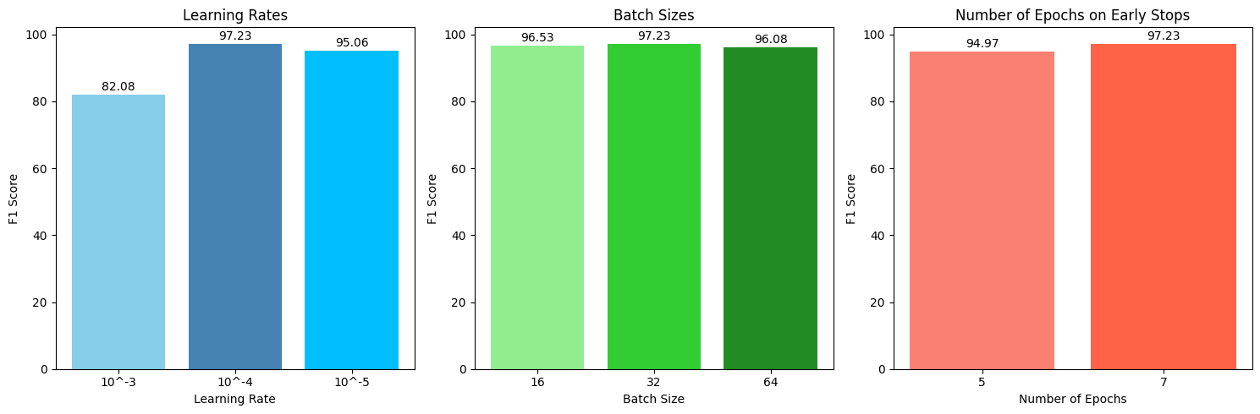The results of all modifications are compared to analyze the impact of changing hyperparameters on the model's performance.*

Figure 78:Hyperparameters Comparison.

*Insights:*

*Learning rate ${10}^{-4}$, batch size 32, and early stopping at 7 epochs seem to provide a good balance between training efficiency and generalization.*

* *Learning Rate ${10}^{-4}$:*
* *A learning rate of ${10}^{-4}$ strikes a balance between convergence speed and stability. It allows the model to make meaningful weight updates during training without causing overshooting or slow convergence.*
* *Batch Size 32:*
* *A batch size of 32 is commonly chosen for its good compromise between training efficiency and generalization. Larger batch sizes can lead to faster training, but they might also result in overfitting, while smaller batch sizes can introduce noise into the weight updates.*
* *Early Stopping at 7 Epochs:*
* *Early stopping with a patience of 7 epochs suggests that the model's performance on the validation set stops improving significantly after this point. It prevents overfitting by halting training when the model starts to specialize too much on the training data.*
* *Generalization:*
* *The good performance on the validation and testing sets indicates that the model generalizes well to unseen data. This is crucial for the model to perform well in real-world scenarios.*
* *Balanced Trade-off:*
* *The selected hyperparameter values represent a trade-off that balances the need for the model to learn complex patterns in the training data and the need to generalize well to new, unseen examples.*
* *Model Complexity:*
* *The model seems to have an appropriate level of complexity, avoiding underfitting (too simple) or overfitting (too complex) on the given video classification task.*

1. *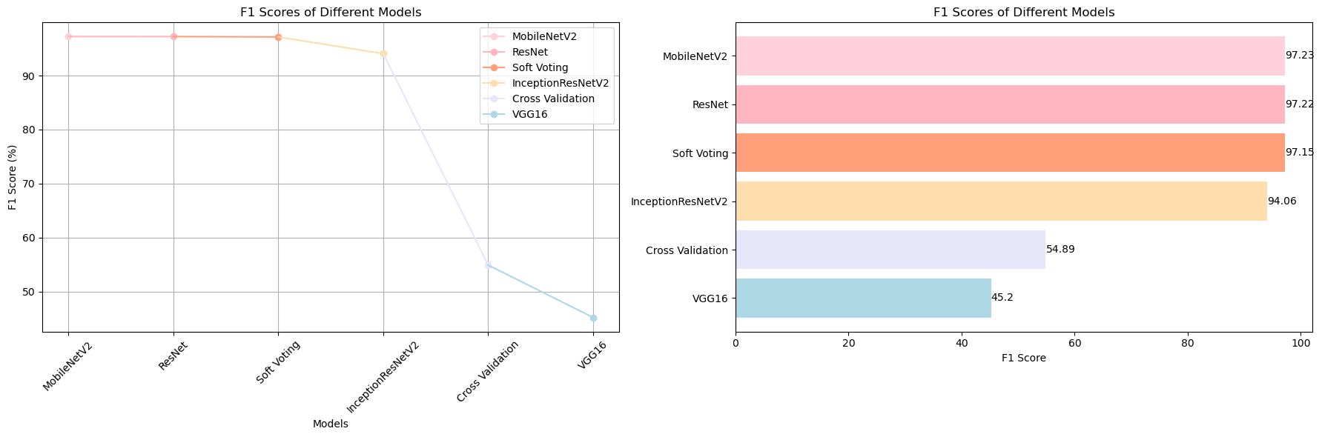Overall Comparison and The Superior Model*

Figure 79:Overall Models and Improvement Comparison.

*The optimal model, as illustrated in the figure[], is the MobileNetV2 architecture trained with the following configurations: 41 epochs, batch size of 32, learning rate set to ${10}^{-4}$,Softmax activation function, and early stopping applied if there is no improvement for 7 epochs. This superior model will be stored and utilized in the subsequent deployment phase.*

*In our pursuit of optimizing the performance of our deepfake detection models—InceptionResNet, VGG16, MobileNetV2, and ResNet50—we undertook various strategies, including video frame splitting at different intervals such as one, two, and four seconds. Surprisingly, the most effective approach across all models proved to be processing frames on a per-second basis. However, a noteworthy setback occurred when employing the VGG16 model, as it consistently exhibited subpar performance across all tested cases.*

*To further enhance the overall performance and achieve a higher F-score, we implemented cross-validation with k-fold set to 5 for the champion model and explored soft voting with the top three models. Unfortunately, despite these efforts, the F-scores generated through both techniques were consistently lower than those obtained from the champion model alone. In a final attempt to boost the performance of our champion model, MobileNetV2, we turned to hyperparameter tuning. Regrettably, these adjustments did not yield the expected enhancements, leaving the champion model's performance largely unchanged. Despite the unexpected challenges and additional efforts invested, MobileNetV2 retained its status as the most effective model for our video deepfake detection project.*

*Steps to get better result:-*

* *Exploring Newer Models:*
* *YOLOv8 and Other State-of-the-Art Models: YOLOv8, which is a popular object detection model. Depending on our specific video classification task, using object detection models or other state-of-the-art models designed for video analysis could be beneficial. YOLO (You Only Look Once) models are known for their real-time object detection capabilities.*
* *Customized Architectures:*
* *Tailor Models to Task: Depending on the nature of the videos, consider creating custom architectures that are specifically tailored to your task. This may involve adjusting the number of layers, units, or incorporating domain-specific knowledge.*
* *Experiment with Different Time Intervals:*
* *Vary Frame Extraction Intervals: Experiment with different time intervals for frame extraction (e.g., 0.5 seconds) to see if certain intervals work better for your specific task.*

*This project aligns seamlessly with the learning outcomes of our graduate program and contributes significantly to our career objectives. Through the exploration and implementation of various deep learning models for video deepfake detection, we have gained hands-on experience in advanced machine learning techniques and model optimization. This project has honed our skills in model evaluation, hyperparameter tuning, and ensemble methods, providing practical insights into real-world applications of artificial intelligence. The challenges encountered have fostered problem-solving abilities and adaptability, crucial attributes in both academic and professional settings. Furthermore, the project's focus on deepfake detection addresses a critical issue in the field of computer vision, enhancing our expertise in a rapidly evolving domain. This hands-on experience and knowledge acquisition not only enrich our graduate studies but also position our strategically for future roles where advanced AI and deep learning proficiency are essential.*

*Despite encountering unexpected challenges and investing additional efforts, the overall success of the project is positive. The thorough exploration of different frame-splitting strategies and model combinations provided valuable insights into the optimal configuration for deepfake detection. The selection of MobileNetV2 as the champion model, despite challenges with VGG16, underscores the importance of model-specific considerations. While attempts to further improve performance through cross-validation and soft voting did not yield significant gains, the project's resilience in adapting strategies demonstrates a commitment to refining outcomes. The success of the chosen champion model, MobileNetV2, highlights the importance of a meticulous approach in addressing challenges and fine-tuning parameters for effective deepfake detection in project videos.*

# 4. Deployment Plan

* *Application Deployment Overview*
* *Website Structure and Configuration*

*“Veriflick" is a distinctive and innovative platform, a seamless blend of "veri" from "verification" and "flick," a colloquial term for films. This name succinctly encapsulates its primary function: verifying the authenticity of videos.*

*Our project is centered around a user-friendly website designed to simplify the video verification process. With the use of HTML, CSS, and Bootstrap, we have developed an interface that is not only easy to navigate but also includes all the essential features for an efficient and engaging user experiencee.*

* *Key elements of the website include:*

1. *Home Page: The gateway to Veriflick, offering a welcoming and informative introduction to our services.*

Figure 80:Veriflick Homepage.

Figure 81:Veriflick About.

**

Figure 82:Veriflick Contact.

1. *Secure Login Page: Prioritizing user security and privacy, this page facilitates safe and straightforward access to our services.*

Figure 83: Veriflick Login Page.

1. *Registration Page: Designed for new users, this page ensures a hassle-free sign-up process, allowing quick and easy entry into the world of video verification.*

**

Figure 84:Veriflick Registration Page.

1. *Video Upload Page: Here, users can submit videos for verification. The page supports various video formats and is crafted to be as intuitive as possible, ensuring a smooth upload process.*

Figure 85:Veriflick Video Upload Page.

1. *Results Page: Dedicated to displaying the outcome of the verification process, this page is designed for clarity, presenting the results in an easily understandable format.*

Figure 86:Sample of Fake Video.

**

Figure 87:Sample of Real Video.

* *Database Configuration*

*To ensure streamlined and secure handling of data in Veriflick, we have implemented a robust MySQL database architecture. This database is structured into two key components, each serving a distinct purpose in our data management strategy:*

* *Part 1: User Information Management*
* *Description: For efficient management of user data, we have established a MySQL database featuring a dedicated table for user information. This table is specifically designed to provide a structured and secure approach to store essential user details.*
* *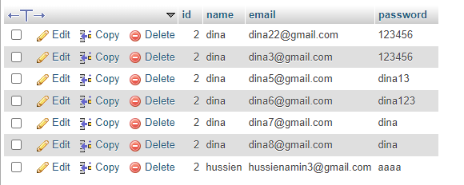Key Elements: It includes fields such as UserID, Username, Email, and encrypted Passwords, ensuring a comprehensive and secure storage of user credentials and personal information.*

Figure 88:User Information Management Key Elements.

* *Part 2: Video Data and Detection Results Management*
* *Description: The second key component of our MySQL database focuses on the management of video data. This table is tailored to store the paths of the uploaded videos along with their corresponding detection results.*
* *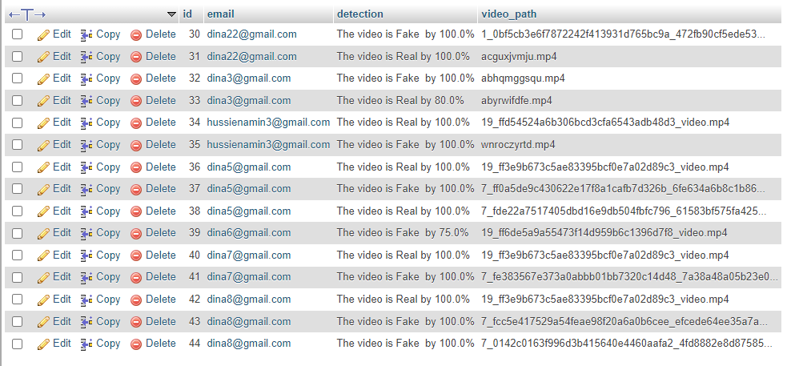Key Elements: This includes fields like VideoID, UserID (linking to the User Information table), VideoPath, UploadDate, and DetectionResult, ensuring a seamless linkage between user activity and video verification outcomes.*

Figure 89:Video and Detection Management Key Elements.

* *The Role of Flask*

*At the core of Veriflick's functionality is Flask, a lightweight and powerful web framework that acts as a crucial intermediary. Here's how Flask facilitates seamless coordination within our system:*

* *Intermediary for Efficient Communication:*
* *Flask's Role: It serves as the connective tissue between our user-friendly website, the advanced video verification model, and our robust MySQL database.*
* *Benefit: This ensures smooth and efficient communication flows, integrating various components of our system harmoniously.*
* *Connecting Diverse Components:*
* *User Interface to Database: Flask helps in managing requests from the user interface, processing them through the verification model, and interacting with the database for data retrieval and storage.*
* *Verification Model Coordination: It plays a pivotal role in sending video data to the model and receiving verification results, linking these with the corresponding user data in the database.*
* *Empowering Precision and Timeliness:*
* *Result Delivery: Through Flask, Veriflick can deliver precise and timely verification results, enhancing the reliability and speed of the video authentication process.*
* *User Experience: This integration not only supports technical efficiency but also elevates the overall user experience, making it smooth and responsive.*

*When deploying the application, it follows a series of routes to cater to different functionalities.*

* *The primary routes are as follows:*

1. *@app.route('/') - Index Route (Main Page)*

* *Description: This is the landing page of the application. It's typically the first page that users see when they visit the site. It could contain information about the application, user testimonials, or a brief guide on how to use the service.*
* *Flowchart Representation: Represent this as the entry point in your flowchart.*

1. *@app.route('/result') - Result Display*

* *Description: After a user uploads a video and it's processed, this route is used to display the results of the video analysis. It shows whether the video is classified as 'Real' or 'Fake' and may include additional details or graphics.*
* *Flowchart Representation: Connect this to the upload route, showing it as the next step after processing the video.*

1. *@app.route('/login', methods=['GET', 'POST']) - User Login*

* *Description: This route handles user authentication. The 'GET' method displays the login form, while the 'POST' method processes the login credentials. If the credentials are valid, the user is redirected to a different page (like the upload page).*
* *Flowchart Representation: Place this as an alternative entry point that leads to other functionalities of the application upon successful login.*

1. *@app.route('/register', methods=['GET', 'POST']) - User Registration*

* *Description: This route allows new users to create an account. It handles both displaying the registration form ('GET') and processing the form data ('POST'). Successful registration typically redirects the user to the login page.*
* *Flowchart Representation: This can be shown as a branch from the main page, leading to the login page upon successful registration.*

1. *@app.route('/upload', methods=['GET', 'POST']) - Video Upload*

* *Description: Accessible only to logged-in users, this route lets users upload videos for processing. The 'GET' method displays the upload form, while the 'POST' method handles the file upload and initiates the video analysis process.*
* *Flowchart Representation: Show this as a progression from the login, leading to the video processing and then to the results display.*

# 5. Conclusions and Future Works

*In this project, we undertook a comprehensive exploration of fake and real video datasets, employing face detection, data preprocessing, and the creation of training, validation, and testing sets. Transfer learning models, including ResNet50, InceptionResNetV2, MobileNetV2, and VGG16, were trained, with MobileNetV2 emerging as the superior model based on f1-score results. Accomplishments included successful frame extraction at different intervals, a video-level evaluation approach, and the implementation of complex model architectures. Noteworthy achievements also involved advanced evaluation techniques such as cross-validation, soft voting, and hyperparameter tuning, ensuring a robust assessment of model performance.*

*The project's conclusion emphasized the potential deployment of the MobileNetV2 model through the Veriflick platform for user accessibility. The results obtained pave the way for applications in building a reliable video forensics system with potential integration into user-friendly interfaces for authenticity analysis. Continuous improvement and exploration of newer models like YOLOv8 were identified as future steps to enhance the system's accuracy and capabilities.*

*The next steps include investigating advanced model integration, expanding and diversifying datasets, optimizing VeriFlick for real-time processing, and conducting in-depth analyses of model performance in various scenarios. The raised questions include concerns about model generalization, real-time processing efficiency, transferability to other domains, ethical implications, and user feedback.*

*Promising paths forward involve the exploration of advanced models like YOLOv8, refining deployment strategies, and staying updated on technological advancements. Future improvements will focus on enhancing the adaptability of the detection system to emerging deepfake methods, with continuous testing against the latest technologies as a key research direction. The success of our soft voting method underscores the potential of ensemble approaches in addressing challenges in the dynamic landscape of deepfake detection, aligning with our commitment to combating digital misinformation and manipulation.*

# 6. References

1. *Malik, M. Kuribayashi, S. M. Abdullahi and A. N. Khan, "DeepFake Detection for Human Face Images and Videos: A Survey," in IEEE Access, vol. 10, pp. 18757-18775, 2022, doi:* [*10.1109/ACCESS.2022.3151186*](https://www.semanticscholar.org/paper/DeepFake-Detection-for-Human-Face-Images-and-A-Malik-Kuribayashi/5670682e4fdc6712cb28619d519376d1459114f8)
2. *M. S. Rana, M. N. Nobi, B. Murali and A. H. Sung, "Deepfake Detection: A Systematic Literature Review," in IEEE Access, vol. 10, pp. 25494-25513, 2022, doi:* [*10.1109/ACCESS.2022.3154404.*](https://www.researchgate.net/publication/358835043_Deepfake_Detection_A_Systematic_Literature_Review)
3. *Pu, J., Mangaokar, N., Kelly, L., Bhattacharya, P., Sundaram, K., Javed, M., Wang, B., & Viswanath, B. (2021). Deepfake videos in the wild: Analysis and detection*
4. *Hu, J., Liao, X., Liang, J., Zhou, W., & Qin, Z. (2023). FInfer: Frame inference-based deepfake detection for high-visual-quality videos. [Paper presented at the AAAI Conference on Artificial Intelligence]*
5. *Rathgeb, C., Tolosana, R., Vera-Rodriguez, R., & Busch, C. (Eds.). (2020). Handbook of digital face manipulation and detection: From DeepFakes to Morphing Attacks. Springer Nature*
6. *illán, A. F. (2019). Mastering OpenCV 4 with Python: A practical guide covering topics from image processing, augmented reality to deep learning with OpenCV 4 and Python 3.7. Packt Publishing, Limited*
7. *Aslam, M. R. (2022, January 14). Muhammad Rehan Aslam's GitHub Profile. GitHub.*
8. *J. Redmon, S. Divvala, R. Girshick and A. Farhadi, "You Only Look Once: Unified, Real-Time Object Detection," 2016 IEEE Conference on Computer Vision and Pattern Recognition (CVPR), Las Vegas, NV, USA, 2016, pp. 779-788, doi:* [*10.1109/CVPR.2016.91.*](https://ieeexplore.ieee.org/document/7780460)
9. *R. Islam and M. A. Shahjalal, "Soft Voting-Based Ensemble Approach to Predict Early Stage DRC Violations," 2019 IEEE 62nd International Midwest Symposium on Circuits and Systems (MWSCAS), Dallas, TX, USA, 2019, pp. 1081-1084, doi:* [*10.1109/MWSCAS.2019.8884896*](https://ieeexplore.ieee.org/document/8884896)*.*
10. *Pallets. (2010). "© Copyright 2010 Pallets. Created using Sphinx 7.0.1."*
11. *Wheeler, J. (2016). "Alexa Skills Kit Development for Amazon Echo Devices with Python." Flask-Ask Documentation. [Online]. Available:* [*https://flask-ask.readthedocs.io/*](https://flask-ask.readthedocs.io/)*.*
12. *Acsany, P. (2023, December 13). "Build a Scalable Flask Web Project From Scratch." Web Development. [Online]. Available: [*[*https://realpython.com/flask-project/*](https://realpython.com/flask-project/)*].*

# 7. Appendices

*The used Roop Face Swap technique leverages deep learning and artificial intelligence to*

*perform face swapping in videos. The process involves cloning the Roop repository, installing*

*necessary dependencies, and downloading a pre-trained face-swapping model. Users can*

*choose to enable GPU support for faster processing. The key functionality lies in the provided*

*Python script, run.py, which takes a target video and a source image as input, utilizing the face swapping model to generate a deep fake video. The tool allows users to explore creative*

*possibilities responsibly, while emphasizing ethical considerations related to deep fake content.*

*Soft voting in ensemble learning, utilizing three models(InceptionResNetV2, MobileNetV2, and*

*ResNet50), improves generalization by leveraging their unique strengths and weaknesses,*

*mitigates overfitting, and enhances accuracy with probabilities. Diverse model architectures*

*contribute to comprehensive pattern recognition, ensuring robustness to variability.Soft voting's*

*versatility in balancing strengths and weaknesses is advantageous, but effectiveness relies on*

*diverse and well-performing constituent models*.